USES OF SEDATIVES DRUGS IN RAPE CASES: A FORENSIC SCIENCE PERSPECTIVE

Abstract
The sexual assault occurs when an individual is forsed, coerced, or presserd into sexual activity without there consent.This includes various forms of non-consensual acts such as veginal, anal, or oral intercourse, as well as unwelcome touching of the private area. The involvement of extreme cases, sexual assusalts also involves the use of drugs or sedatives that reduce a oersons ability to resist, impair judgement, or cause unconsciousness , thereby subjecting the victim to curelty and abuse. This research paper examines the use of sedative drugs in cases of sexual assaults , and rape from a forensic science perspective. This paper also focuses on the types of sedatives commonly used as date rape drugs, their effects on victims and the challenges involved in their forensic detection. The study also analyzes the legal framework governing such offences under the Bharatiya Nyaya Sanhita, along with the role of forensic evidence in Indian courts. Additionally, the paper highlights the legal and procedural challenges faced during investigations and prosecution of drug-facilitated sexual assual cases.
Keywords: Sedative Drug, sexual assault, rape, forensic science.

Research Methodology
This research paper is based on doctrinal and non doctrinal research methodology. The paper analyses sexual assault in which an individual is subjected to force or pressure into the sexual activity without their consent.The paper also examines the two common forms of drug facilitated sexual assault namely proactive drug facilitated sexual assault and opportunistic drug facilitated sexual assault. The paper also discuss about the various types of drugs that is being administered in cases of drug facilities sexual assault and there role incapacitating victims. This paper also covers the legal aspects of drug facilitated sexual assault , that is provided in Bhartiya Nyaya Sanhita and highlights the various challenges faced by the judiciary in the investigation and implementation of laws relating to the misuse of sedative drug.

Introduction
The sedative drug have a depressant effect on a body. These drug can make the person insensitive to pain, worry, and emotions. Due to their calming effects, they may induce relaxation, drowsiness, or unconisciousness in the user.
The sedative drug act by depressing certain parts of the nervous system and influencing neurophysiological functions. As a result the central nervous system is affected, leading to a reduction in metabolic rate. This causes a decreases blood pressure, slowing of respiration and suppression of hunger. The addiction of these drugs case cause weight loss.
The sexual assault occurs when an individual is forced or pressured into the sexual activity without their consent. This involves acts such as vaginal, anal or oral without the consent or without unwelcoming touching of the private area. The involvement of extreme cases also involves the usage of a drug can lower down the person ability to resist and even which is subjecting to cruelty or abuse.
The alarming form of a particular Drug-Facilitated Sexual Assault (DFSA) is oftenly called as Date Rape or Drug Rape. In the various situations, the person is purposely given the alcohol or the drugs without the knowledge and it will render them incapable of giving the consent, due to which the victims are unable to defend themselves or even recall the incidents what happened with them. These assaults are difficult to prove and to report especially in later cases. This is important to analyse the drug facilitates sexual assault always does not dissolved in drinks or Sometimes the offenders use to take advantage of someone who have being already intoxicated heavily from drinking on their own exporting them to a vulnerable state to commit the assault.
There have a two common forms of DFSA (Drug- facilitates Sexual Assault), the first is Proactive DFSA (Drug-Facilitated Sexual Assault). In this the attacker being deliberately gives a victim a drug which will weaken the ability to resist, And the second Drug-Facilitated to Sexual Assault is Opportunistic DFSA (drug-Facilitated Sexual Assault) that is where the perpetrator sees a chance to act when someone is already heavily Drunk as they are barely and completely unconscious. This is being caught as “date rape drugs” or sometimes it is “club drugs”, this is a substance which is used by someone to physically weak other or confused or unconscious. The drugs are frequently added in the drink secretly and making the victim unable to defend themselves or even Unaware about the what is happening. The kind of assault survivors often describe the strange experience including the feeling far more intoxicated than expected, the amount they drank their memory blackouts they have experienced. The injuries after waking up which they can’t explain and there is also a possibility that they have been drugged.
Some of the most common substances that link to this assault includes Rohypnol(flunitrazepam), GHB (gamma-hydroxybutyrate), Ketamine and Alcohol.
Gamma-hydroxybutyrate or GHB is a medication that is being used for many purposes and is not a safe and legal. Many of the bodybuilders have turned to it because of its potential and the support of muscle growth while others use it recreationally, and it is being used frequently alongside with other substances. Many people seek it out in a social or a party setting Because it is known for the production of sexual assaults like Hide and touch and the lower Inhinitions.
One of the reasons that GHB (gamma-hydroxybutyrate) has been widely misused due to Cheap and not difficult to make. GHB usually takes 15 to 20 minutes for its sedative effects to start and they may last for hours. The higher dose of the drug has become more dangerous. This may result in nausea Breathing difficulties or even a death. When GHB and alcohol are combined, the risk may increase due to they have protentional serious impair the body essential process.
In recent years, GHB(Gamma-Hydroxybutyrate) help in linking the rave culture and the parties similar to other drugs like ecstasy both of which can link and produce euphoric or disorienting effects. Unfortunately, it has been in many sexual assault cases of drug-facilitated sexual assault which is due to ability to impair memory and reduce of physical resistance.
This is being detected in the body timing is critical as its breakdowns quickly and in many cases, it may not show up in a test if more than 12 hours have been passed since ingestion.
Rohypnol is also known as flunitrazepam, it belongs to benzodiazepine family of drugs. Rohypnol is mostly use in illegal activities and leave impact on health. It is very intense sedative effects , also causing drowsiness, deep relaxation and even memory lapses. It is used in few countries to treat a severe insomnia and pre-surgical sedative, but it is banned in India due to high potential for abuse. Due the Rohypnol use the victim has suffer from sleep, extreme seizures, anxiety and drowsiness.
Ketamine is most commonly used in an anaesthetic for surgical procedures. It helps in pain relief, sedation, and amnesia while preserving breathing and airway reflex. Ketamine is used for animals so that they get relief in pain and memory loss effects. When it gives to the humans, the individual temporarily unable to feel pain and unable to move. The ketamine can leave the impact on body which cause the heart rate , delirium, hypertension, post- traumatic amnesia.

Types of Date Rape Drugs
The drugs are most commonly used as date rape drugs are GHB, also known as gamma-hydroxybutyric acid, and benzodiazepine’s (such as flunitrazepam, other names are Rohypnol or forget me drug, or ruffes , forget-me-pill; a vetenarian anaesthesia like ketamine; In American 1997 study shows that alcohol is used. The alcohol is frequently used in date rape drugs because it is legal and easily available in the market. The assailants use the alcohol because it is cheap and victims are often drink willingly and may encouraged them to drink the alcohol to lose the consciousness.
- Gamma-Hydroxybutyric Acid
The y-Hydroxybutyric acid, also called as gamma- hydroxybutyric acid, GHB , or 4- hydroxy butanoic acid is often naturally occurring neurotransmitter and depressant drug. The GABA, glutamate and glycine are present in particular brain areas. The GHB is often used in medicine as a general anaesthetic and also help to treat the cataplexy, narcolepsy and alcoholism. It is frequently used illegally for performance enhancement , recreation and date rape.
It is offenly used in the form of salt, for example y-hydroxybutyrate (NaGHB, sodium oxybate or Xylem) or potassium y-hydroxybutyrate (KGHB, potassium oxybate). As a result of fermentation GHB is being used and we can also find the GHB in beers and wines , beef and small citrus fruits.
GHB can be made by mixing one drug to another drug with the help alkali hydroxide for example sodium hydroxide, which form a GHB salt. It does not require high-tech laboratories like other drugs needs but it can be manufactured in private homes by low level producers or GBL can be easily consumed. The GHB can be colourless and odourless. In 1990s, the GHB was used in club drug because it is easy to add to drinks. At the time of consumption the victim may feel groggy, sleepy and unconscious. The victims are unable to recall the events happened during the intoxication.
This is being difficult to detect how ghb used in istimulate the rape because difficult to detect in the urine sample.
- Ketamine
In anaesthetic surgery, the use of ketamine for the treatment of depression and the abuse of a drug FDA have improved the use of ketamine as an anaesthetic Which will help in sleep for a surgery and to prevent the brain and the discomfort. In the trails of clinical the ketamine has been used for the label of the depression due to the hallucinogenic properties the drug abuse is Illegally and is also known as date Rape drug which is causing short term memory loss.
The time when the anaesthesia is given the ketamine is being an intravenous injection. In 2019, the FDA have approved the specific types of various depression and out of which ketamine is used oftenly for the treatment of depression using the form of racemic ketamine.
Under the control of DEA substances Act the ketamine is being controlled substance which is being classified in schedule III drug. In the schedule I and II the ketamine is being potential for abuse. The ketamine abuse may result into the lowering down the potential and the physical dependence. But it has the high psychological dependence. In US the drugs that has been classified as schedule 3 is being accepted for the medical treatment use. Due to hallucinogenic and dissociative effect of the ketamine’s have been abused illegally. In an affect the use of ketamine the changes are of sensory experiences dreams like states.
- Rohypnol (flunitrazepam)
Rohypnol (flunitrazepam) also called as circles, roofies, la Rocha , Roche, rape and forget – me pill, Mexican Valium. For inducing the anaesthesia as a pre medication surgical procedures for the treatment of short-term insomnia.
In 1990s from that time the Rohypnol has been used illegally to reduce the depression which is caused by the abuse of stimulants, they are cocaine and methamphetamine, and being also aid for sexual assault. In the drinks of victim the so-called date rape drug is being unknowingly added in the drink often in the party b, or bar. Due to the protostome strong amnesia the victim may have limited or have no memory of the assault. Due to the amnesia the individuals are unable to remember the events of certain experiences while udder an influence of drug. This effect of Rohypnol has been using illicitly for aiding the sexual assault. The victim in the case of partial amnesia is unable to recall the assault, assailant, or the events which are being surrounded at the time of assault.
- Alcohol
The alcohol is a legal substance which is used oftenly in the case of drug- facilitated sexual assault or date rape. This has not been classified typically in a date of drug, alcohol can able to impairing of the judgment, and the coordination and the cognitive function this makes the perpetrator easier for taking the advantage of an individual is under an influence. The victims are being intoxicated by the perpetrator to advantage of victim. By using the alcohol for the intoxication of victim the perpetrator may have been able to decrease the ability of the victim in resisting and making of a clear decision. The perpetrator also provide victim who is already being intoxicated and providing them with additional alcohol. The alcohol may affect the ability of making the decisions or judgment and increase the vulnerability. Many of the attackers have used one of these drugs along with the alcohol. The alcohol can itself can also use to keep someone in defending themselves knowing what happening to them or remembering it later. In criminals it is used as most common subject for such purposes. Fifty percent of assault cases were under the influence of alcohol.
Z drugs refer to the zolpidem, zopiclone, zaleplon. These drugs are especially because of rapid onset can be used to detected for a short time in facilitating the sexual assault.
The club drugs such as ketamine, and GHB have becoming increasingly popular among young people in India. The use of this drug has been illegal in India and the distribution is strictly regulated.
The sexual assault occurs an individual when someone is forced or pressured into the sexual activity without their consent. This involves the type of sexual assault is being forced Such as vaginal, anal or oral without the consent or without unwelcoming touching of the private area. The involvement of extreme cases also involves the usage of a drug can lower down the person ability to resist and even which is subjecting to cruelty or abuse.
The use of sedatives in the cases relating to sexual assault, rape is being primarily governed by the Bhartiya Nyaya Sanihta. The concept of consent has been focusing in the framework address of the use of sedatives. While the critical elements in proving the rape while the person is incapacitated by the sedative their ability of giving the free and voluntary and the consent which to be informed is absent.

Bhartiya Nyay Sanhita and Consent:
The legal provision that is primarily deals in rape provision is section 63. In this the law has been amended the ingredients of what constitute the rape. In the facet it does not mention the date rape drugs. The act covers the act that through the clauses of consent. Clause(v) of the section primarily deals with the cases involving in the sedatives. It states with the consent when the time of giving of such consent by the reason of unsoundness of mind or by the intoxication or administration to her personally, or through the any other stupefying substance or foofunwholesome substance as she gives her consent as she is unable to understand the consequences to that to which she has given a consent. Clause (iv) with her consent when at time of giving by reason of unsoundness of mind or intoxication or administration by him. By her consent she is unable to understand the consent of it.
These clauses have been critically criminalizing the drug facilitated sexual assault by the consent of a person who is being drugged or being incapacitation is not reasonable. The burden of proving that the substance of which is being administered with the intention to helpless the victim and the victim is giving consent is unable to understand the consequences of the act at the time when the stupefying substance or a drug is being administered.

Forensic Evidence in Indian Courts:
The forensic science provides crucial evidence in a drug facilitated sexual assault cases in India. But at the sametime it faces some of the challenges:
- Sample collection: wit the timely in collection of samples of biological such as blood, urine , hair. Due to the lack of awareness and the effect related to amnesiac of the drugs, in such a cases victim may delayed in report in reporting of crime which can be become difficult in detection of crime.
- Challenges in detection: as many of the sedatives like GHB are cleared from the body very quickly. This short life may possess a crucial problem in forensic science laboratories. In the blood or urine the drug is not detectable as without the quick police report and the medical examination.
- Hair analysis: by the help of hair sample it helps in detection as the hair retain the drug for a longer period of time it helps in more extended timeline detection.
- Corroborating Evidence: the report of forensic toxicology has been used in corroborating the testimony of victim and help in proving that they were incapacitated by a substance. At the time of proving the testimony it helps in strengthen the case of prosecution by establishment of lack of consent.
- Amnesia: The Sedative drugs have been oftenly cause intergrade amnesia and living the victim with no little memory of the assault. The courts also being started acknowledge the memory lose is being a direct result of a crime itself. And should be not taken as a ground to discrediting the testimony of victims.
The conclusive toxicology report have been automatically let to acquittal and now the court are willing to rely upon the victim testimony with the combination of medical report the injury and the evidences that are being presented before the court as circumstance evidence.
Legal and Procedural Challenges:
Despite of the provisions the DFSA cases in India is been challenging in a result of many factors:
Lack of specific law: as the section 63 specifies the issue and there is no standalone act for that matter to which it is wholly dedicated to drug facilitated to sexual assault. This can result in the variations in cases it is to be deal and handled by the law enforcement and the judiciary.
Victim blaming: there is a societal tendency of blaming the victim especially when it was consumed voluntarily or in the private sitting the assault has been occurred. For victim it may lead to creation of hostile environment and this may discourage them in reporting the crime.
Prosecution Burden: in this the burden of proof is lie upon the prosecution in proving the case beyond the reasonable doubt as the substance which is being administered is without the consent of a victim and without the knowledge of the victim in such a
scenario they have been rendered incapable of consenting.

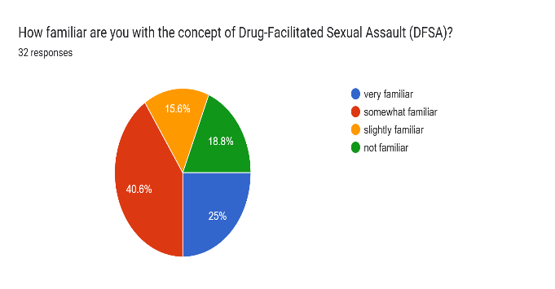
Observation
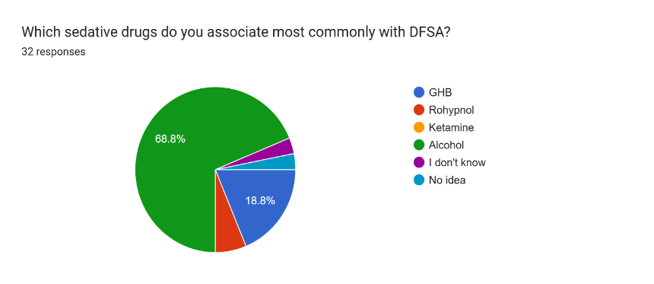
The majority of respondent had a basic awareness of Drug-Facilitated Sexual Assault with 65% reporting some familiarity. However, their understanding of specific sedative drugs such as GHB , Rohypnol, or Ketamine was low . this shows a gap in knowledge about the pharmacological details of DFSA . High Association of Alcohol with DFSA a significant 68.8% of respondent identified alcoholas the substance most often linked to DFSA , more so than traditional date rape drugs . This reflects a belied that DFSA is more than to drugs in the strict pharmacological sense. Growing concern about increasing DFCA cases in India Three fourths of participants felt that the misuse of sedavtives for sexual assault is on the rise in India .

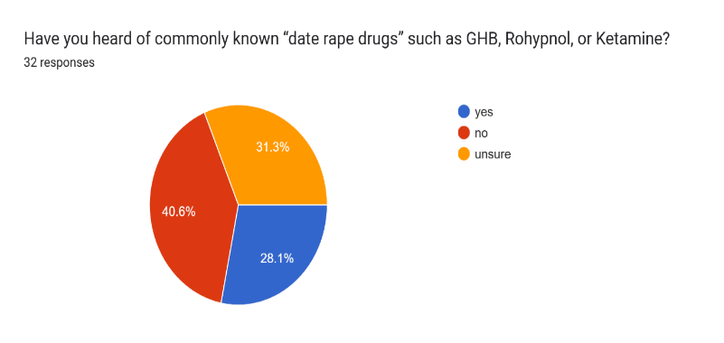
This suggests growing public concern and possibly greater awareness of DFSA-related incidents in the media and society. Limitedknowledge of forensic Toxicology limitations Awareness of rapid drug metabolism , especially the short detection window for GHb, was notably low, only 46.9% knew of this important limitation.
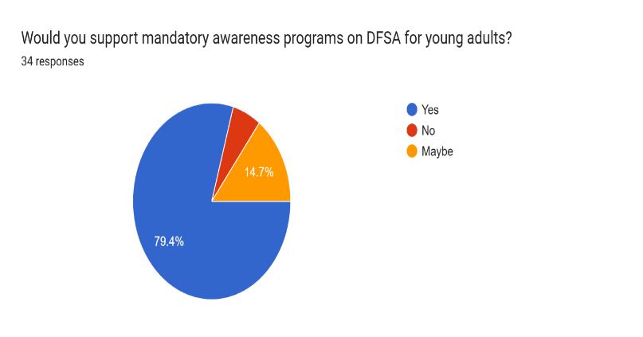
Nearly 69% were unware that hair analysis can detect DFSA drugs long after exposure. This indicates a lack of public understanding of forensic toxicology’s capabilities and limitations. Strong recognition of the forensic Importance of Timely Sample Collection A large majority 93.8% viewed the quick collection A large majority viewed the quick collection of biological samples, such as blood and urine, as essential in DFSA cases. This shows an understanding that forensic evidence is very time sensitive. This highlights public awareness of the increased incapacitating effects of these combinations. Perception of legal insufficiency only 25% believed that the current laws under BNS section 63 adequately address drug- facilitated rape, while 65.6% supported creating a separate law for DFSA, this suggests a feeling that there are gaps in the existing legal framework.

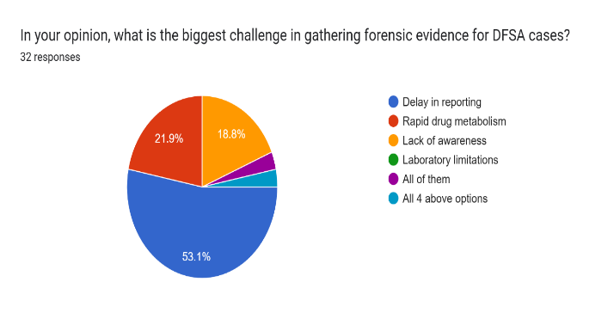
Challenges in DFSA Evidence collection Recongnized over half of the respondents 53.1% identified delays in reporting as the biggest issue, followed by rapid drug metabolism and lack of awareness. This aligns with known challenges in DFSA investigations worldwide.Victim -Blaming as a Barrier to reporting An overwhelming 81.3% agreed that victims often hesitate to report incidents due to fear of being blamed.This indicates ongoing social and cultural barriers that may delay reporting and hinder the recovery of forensic evidence. Demand of preventive measures and Awareness programs respondents strongly favored preventive measures in Public institutions 78.1% and mandatory
DSFA awareness programs for young adults strategies for preventions. Public preference for punitive and awareness – based solutions while stricter punishments were the most preferred measure 46.9% there was also support for combining public awareness campaigns with strengthening forensic practices. This reflects a broad understanding of the various aspects of DSFA prevntions.

Suggestion
- Enhancement of forensic laborator capability in India, there are not enough toxicology laboratories in india that can detect rapid – acting sedavties. To provide for better forensic results, all state forensic laboratories in India need modern day technology.
- Police officers need to be trained in identifying DFSA symptoms as soon as they arrive on they arrive on the scene and to collect evidence immediately.
- Raise Public Awareness of DFSA Drugs and Develop Educational Programs for Safety according to the study most people do not know what DFSA drugs are or how they work. So community centres should conduct regular awareness workshops on DFSA.
- Doctors and nurses should receive specialised training on how to collect blood, urine, and hair samples properly.
- Bars, clubs and restaurants should be encouraged to implement anti-speaking measures, such as sealed cup covers and CCTV cameras. Staff who work in nightlife venues should be trained to identify suspicious behaviours.
- Stronger Punishments for DFSA offenders , stricter jail terms for drugging with the intention to commit sexual assault. Higher punishment when sedatives are mixed with alcohol and also additional penalties for drug suppliers who provide sedatives illegally.

Conclusion
The law India have been recognised the person so has been incapacitated cannot be said to be legally consent to commit a sexual activity. The Bhartiya Nyaya Sanhita have been provided the legal basis for the prosecting the crimes and the important role have been played by the forensic science which help in providing the evidence that is to be needed in providing the conviction. Therefore, the forensic limitations and the challenges that is being faced for the timely reporting under the limitation of forensic and attitudes of society continue to hinder the justice for the victims of the DFSA.

Refrences

- Sajeev, D. (2021). Drug-facilitated sexual assaults: An impediment to the progression of Indian society. IP International Journal of Forensic Medicine and Toxicological Sciences, 6(1), 1–3. https://ijfmts.com/archive/volume/8/issue/2/article/2328#:~:text=In%20low%20doses%2C%20it%20can,incapacitated%20and%20unable%20to%20resist.
- Sonone, S. S., Jadhav, S., & Sankhla, M. S. (2020). A forensic aspect on drug facilitated sexual assault. International Journal of Forensic Sciences, 5(1), 000174. MedCrave Online. https://medcraveonline.com/FRCIJ/a-forensic-aspect-on-drug-facilitated-sexual-assault.html#:~:text=A%20drug%20that%20has%20been,Muscle%20Relaxant%20(Carisoprodol%2C%20Cyclobenzaprine%2C
- Pal, R., & Teotia, A. (2018). Date rape drugs and their forensic analysis: An update. Journal of Forensic Sciences & Criminal Investigation, 7(5), https://www.researchgate.net/publication/254258887_Date_rape_drugs_and_their_forensic_analysis_An_update
- Sharma, B. R. (2019). Forensic science in criminal investigation & trials (6th ed.). Universal Law Publishing.
- Modi, J. P. (2016). A textbook of medical jurisprudence and toxicology (25th ed.). (K. Kannan, Ed.). LexisNexis.
- Bharatiya Nyaya Sanhita, 2023, No. 45, Acts of Parliament, 2023 (India).
- Subrahmanyam, B. V. (2019). Parikh’s textbook of medical jurisprudence, forensic medicine and toxicology (9th ed.). CBS Publishers & Distributors.
- Charan, J. L., & Manikyam, K. S. (2022). Forensic science and its limitations in rape and murder cases in India. International Journal of Law Management & Humanities, 5(1), 1276–1285. https://www.researchgate.net/publication/369268827_Forensic_Science_and_its_Limitations_in_Rape_and_Murder_Cases_in_India
- White, M., & White, C. M. (2023). The impact of sedative hypnotic drugs on hallucinated sexual assault or sexual fantasies involving health professionals: A systematic review. The Journal of Clinical Pharmacology, 63(6), 624–633. https://pubmed.ncbi.nlm.nih.gov/36895011/
Correspondence address:

Author: Anand R*, LLM (criminal law and forensic)
Banasthali Vidyapith, Niwali, 304022
rajlaxmi.h90@gmail.com
Co-Author: Rajput S*, LLM (criminal law and forensic)
Banasthali Vidyapith, Niwali, 304022
001shobhachauhan@gmail.com
P*, LLM (criminal law and forensic)
Banasthali Vidyapith, Niwali, 304022
nikkimittal024@gmail.com

Bhartiya Nyay Sanhita 2023

