Forensic Challenges and Medico-Legal Implications of Fatal Anaphylactic Shock

Abstract
Anaphylactic shock is life threatening and endangering which is the systematic reaction and a hypersensitivity reaction. In the forensic pathology the establishment of anaphylaxis as the main reason of cause of death is challenging because of the clinical history is often unknown and there are nonspecific findings of postmortem. At the time of anaphylaxis, the patient may usually experience the hives, hypotension, and itching that will lead to dizziness, unconsciousness and which may also cause the swelling of the upper and the lower airways that may lead to the respiratory distress. The autopsy should be conducted as soon as the abnormal accumulation due to fluid and the swelling of larynx which will lead to narrowing of air way and may cause breathing difficulty it is laryngeal oedema that recedes after the death and which is not being observed.
Keywords: Life threatening, forensic pathology, postmortem, allergen

Research Methodology
The research uses the doctrinal and nondoctrinal research methodology.

Introduction

Meaning
Anaphylactic death is lethal condition which is occurred due to the rapid exposure to an antigen that is producing medical feature of generalize shock to the respiratory distress, severe hypotension and death. This shock is life threatening and endangering which is the systematic reaction and a hypersensitivity reaction. This is a systematic reaction of medical emergency that is the necessity for the forensic examination because of uncertainty of cause of death. The shock can be occurred at home, in hospital or in public.
This is the life threatening as it is commonly associated with release of massive circulation potent, vasoactive products from the mast cells that is often the medications that usually affect the constriction or the dilation in the blood vessels and influencing the blood pressure and flow of blood in the vital organs. This vasoactive chemical potentially affecting the main integrity of the life sustaining organs and it causes diseases that will be affecting heart and blood vessels is the cardiovascular and pulmonary organ is the complex network of organs and structure that performs exchange of gas in the body, that is allowing the body to inhale and exhale of the carbon dioxide.
In the forensic pathology the establishment of anaphylaxis as the main reason of cause of death is challenging because of the clinical history is often unknown and there are non-specific findings of postmortem. This is typically relied upon the comprehensive investigation which includes a detail explanation of death scene investigation, a complete autopsy, postmortem toxicology and histological analysis.
Out of 5 people one may have the anaphylactic reaction within the 12 hours of the first. This is usually called biphasic anaphylaxis.

Common Trigger
The anaphylaxis in most of the cases is commonly due to Triatoma bites,
Hymenoptera stings, foods, antibiotics and due to certain medications. The most common triggers are due to certain food, medicines, and the insect stings.
This will all be due to mass cell activators such as the certain medication and radiocontrast media. Sometimes the death due to anaphylaxis is to be labeled as idiopathic when there is no etiology can be found.

Causes
Because of anaphylaxis to an exposure of an allergen in release of chemical like histamine. Commonly triggers are:
Foods: peanuts, shellfish, wheat, milk, seafood
Medications: commonly example
penicillin, anesthesia, ibuprofen, aspirin
Insect stings and bites: venom from the insects that will include like bees and wasps, yellow jacket, honeybee, hornet, imported fire ant.
Latex: this is rubber products.
This commonly happens when the immune system of body releases the chemicals which may lead to cause the symptoms of sudden drop in blood pressure, which may narrow down the airways and may cause the swelling.

Symptoms
The main first sign of the anaphylaxis reaction it may look typically the symptoms of allergy that is the runny nose or the rashness of skin. But in within about 30 minutes, more of the serious sign usually appears.
They are usually:
- Coughing and wheezing
- Tightness, itching, pain in the chest
- Weakness, dizziness, fainting and confusion
- The shortness in the breath and rapid heartbeat and trouble in breathing
- Swollen of lips and itchiness in the lips or in the tongue
- Cramps, vomiting, diarrhea and the stomach pain
- Slurred speech
- Pulses are weak and the paleness
At the time of anaphylaxis, the patient may usually experience the hives, hypotension, and itching that will lead to dizziness, unconsciousness and which may also cause the swelling of the upper and the lower airways that may lead to the respiratory distress. The one of the clinical causes to manifest in anaphylaxis due to high pitch of whistling sound made while breathing due to the sudden contraction of the smooth muscles which is being surrounding the passage of air in the lungs that is commonly called bronchi which may narrow down the airways and may make breathing difficult.
The whistling sound made during the breathing that is commonly called wheezing that tends to occur in patients with the history asthma. Other symptoms of anaphylaxis are due to the effect of the release of the chemical that the immune system releases are commonly called as histamine, platelet activating factor that is the a potent of lipid mediator involved in inflammation, immune responses, and blood clotting, and proteases on the cardiovascular, respiratory and the cutaneous pigmentation system.
Few people may also retain the feeling a sense of doom that is the right before the attack is the rapid feeling of unfound that something life threatening is going to happen. The symptoms may also move towards from shock to the loss of unconsciousness

Diagnosis of Anaphylaxis
The diagnose of anaphylaxis is bit challenging as it is due to a group of symptoms and sign and the clinicopathological characteristics which may or may not have a basis of genetic which is collectively defined as the abnormal condition and the variability of its sign that something is happening as well as the duration is transient. At the time of surgery which is perioperative anaphylaxis is the case the signs and its symptoms may not be obvious in the case of draped and anesthetized patient. During the childhood the anaphylaxis is being confused due to the irritability, because of the dangerous situation when the object of solid and semisolid is inhaled and is lodges in the lungs in the airway or lungs is the foreign body aspiration and due to the threating medical emergency in which the immune system overreacts lead to the infection and caused the widespread inflammation, organ damage and the may potentially leading to the organ failure and death is mean as sepsis. Anaphylaxis is singular, biphasic. Hence the patient to be treated in accordance to the recurring symptoms and to be monitored closely. Due to the result of various factors that will resultant into the higher risk of anaphylaxis that will include the mass cell disease, the medications like beta blockers.

Fatal Anaphylaxis
Anaphylaxis can be lethal at the time especially when the adrenaline is the neurotransmitter a treatment that is used to treat the life-threatening conditions, if the medication is delayed or it become ineffective because of the association use of drugs such as the beta blockers. When the patient is suffering with the uncontrolled asthma then the patient will be at higher risk of anaphylaxis. If the anaphylaxis is addressed instantly then it will be managed successfully. In the majority of cases the main cause of death due to anaphylaxis is the hypoxic respiratory arrest.
The pediatric patients suffering from severe anaphylaxis that will lead to the hypoxic respiratory arrest as a result of intense bronchospasm so the necessary treatment need to be completed rapidly as possible.

Study of Anaphylaxis Death
The morphology study is usually nonspecific. The lethal outcome is not because of certainty but it is being estimated that the about one percent of anaphylaxis incidence per year. The rapidly occurring death the only finding with the help of viscera congestion. In the prolongs study the main findings are mainly the obstruction of airway or lungs and causing the edema and mucus plugging this is the accumulation of the mucus that will obstructs the airways in lungs. Forensic Pathology Reviews, Vol. 3 Edited by: M. Tsokos Humana Press Inc., Totowa, NJ 267
268 Edston and Hage-Hamsten examination occasionally reveals edema when the tissues of body accumulate too much of fluid in the respiratory mucosa, eosinophilic mean the condition a type of white blood cell is being associated with inflammatory responses and epithelial desquamation , it is the process where the dead epithelial cells are being shed from the surface such as the skin outermost layer, the stratum corneum from the internal tissues. The number of the mast cells in the different organs of the body in the case of anaphylactic death is cannot be properly evaluated as it is difficult in postmortem tissues. The anaphylaxis postmortem in few cases confirm due to the immunological method to quantify mast cell especially in the test of tryptase. As the knowledge of patient history and the circumstances of the death is of the major importance when the investigation is suspected of anaphylaxis shock.
As per clinically the anaphylaxis can be diagnosed and examined on the basis of most in the case of severe symptom from the involvement of any organ systems. In the above discussion it is being stated the anaphylaxis may occur outside the hospital and this may also be triggered by external factors and therefor it may also be in mistakenly considered and being classified as accident or may be possibly suicide or homicide basis of circumstances.

Stages of Anaphylactic Death
Typically, an allergic reaction and its associated signs occur gradually. But it can quickly get worse. Most likely, your symptoms will start out mildly and gradually worsen. Initial response detection allows you to seek treatment before the signs worsen or become potentially fatal. Some of these phases are:
Stage 1: You may not be aware that you are experiencing an anaphylactic reaction yet; it may appear to be a mild allergy. You may experience itching, notice that your skin is red or swollen with hives, and your nose may begin to run. It is important to be aware of these symptoms, particularly if you are aware that you are at risk for anaphylaxis.
Stage 2: More parts of your body are experiencing worsening symptoms. You might have hives or a rash over a larger area. Your eyes may begin to water, and your visage, lips or tongue may swell. You might find it difficult to swallow. Additionally, you might experience diarrhea, vomiting, or stomach pain. If your symptoms continue to worsen at this point, you should seek help immediately.
Stage 3: Problems with respiration may worsen as your symptoms worsen. You might experience abdominal discomfort and an unsteady rhythm. Additionally, you might experience lightheadedness, dizziness, or even fainting. Anaphylactic shock is another name for this stage.
Stage 4: The symptoms you are experiencing are now potentially fatal. Your pulse is weak, and your blood pressure has decreased. Your airways continue to swell, which is causing your blood to flow improperly. An allergic reaction can cause cardiac arrest and even fatalities when indicators are at their worst.

Post Mortem Examination
If the death is resultant due to anaphylactic shock the history should be in a result of possible cause. The autopsy should be conducted as soon as the abnormal accumulation due to fluid and the swelling of larynx which will lead to narrowing of air way and may cause breathing difficulty it is laryngeal oedema that recedes after the death and which is not being observed. The post mortem examination may be grouped under:
- External Examination
- Internal Examination
- Microscopic Findings

External Examination
The place of injection and the sting must be seen, analyzed and photographed and should be cut surgically with the 5 cm margin of the skin and underlying tissue for the examination in laboratory of antigen. There may also be oedema of face, eye lid, conjunctivae and lips all associated with angioneurotic oedema, it is the painless swelling under the skin which is being triggered by an allergy to animal, food, or medication. Asphyxias changes include subconjunctival hemorrhages and froth in the mouth and nostrils. Generalized hemorrhage petechial that is the tiny round, brown, purple spots due to the bleeding in the skin which is resultant of minor trauma due to a life threating medical condition which leads to a dangerous drop in blood pressure and this my result in in adequate blood flow to the vital organs like the brain, heart, and kidneys. It is vasodilatory shock and increase of histamine.

Internal Examination
Laryngeal blockage could result from glottis and epiglottis oedema that spreads to the vocal cords. Shortly after death, this oedema goes away. For a lasting record, photos of the Roman glories and epiglottis should be taken from above.
There are frothy fluid and mucus in the tracheobronchial tree. The lungs are heavier than normal, very swollen, and have alternating areas of pink emphysema and plum-coloured collapse. Visceral pleura frequently exhibits dispersed petechial haemorrhages. When cut, the lung oozes a lot of frothy blood. If possible, a chest x-ray should be done.
The Internal heart may have pectoral bleeding, while there may be mild transudation of straw colour in the pericardial sac. Sudden lung failure causes the right side of the coronary to develop. A blood sample ought to be kept for drug levels and immune analysis (antibody titre). The internal organs of the 7bdomenn are severely congested. Sometimes either of the kidney parts have swelling or haemorrhage. There could possibly be larger and hyperactive lymphatic vessels in the lymphatic system and at the portal vein of the liver.
The brain frequently exhibits petechial haemorrhages in the white matter along with diffuse congestion.

Microscopic Findings
Quick autopsy causes laryngeal oedema to go away, but microscopic examination still shows subcutaneous throat inflammation and lymphocyte infiltration.
Lung histology demonstrates focal or diffuse respiratory dilatation (acute emphysema) that alternates with bronchial constriction and collapse (histamine effect). There is noticeable dilatation of the pulmonary capillaries and arteries.
The lymphatic nodes located within the aorta hepatis, the mesentery, and the Peyer’s patches of the small intestine may all exhibit hyperaemia and sporadic haemorrhages. Eosinophilic leukocytes are visible in the red pulp of the spleen.
The doctors must first determine whether the patient is allergic to or sensitive to penicillin or any other type of local anaesthetic before giving the injection of these medications, as well as desensitization injections using pollen extracts. They must also take extra care and caution, as any reasonably prudent person would.

Since anaphylaxis is a life-threatening, systemic reaction, also known as a generalized hypersensitivity reaction, and is characterized by the rapid development of life-complicating issues involving the airway, such as pharynx or throat swelling, breathing bronchospasm with tachypnoea, circulation hypotension, or ventricular fibrillation, or a combination of these, particularly because they are linked to changes in the skin and mucosa, the symptoms of anaphylaxis can also be caused by other conditions, such as an acute cardiovascular or respiratory event. Therefore, an analysis of allergen-specific immunoglobulin E antibodies should always be performed in conjunction with the measurement of tryptase serum. If no allergenic is known, a panel of common food and airborne pollutants should be measured and tested. When looking into suspected anaphylaxis, it is crucial to know the patient’s history.

The sudden demise of the industrialist Sunjay Kapur has triggered the whole internet. While he was playing polo it is alleges that he swallowed something like sting. At the instance it was alleged that the death was due to anaphylactic shock but after the postmortem examination was conducted in Surrey Coroner’s office, the death was due to the ischemic heart disease.

At the instance of report it was suggested the death was due to swallowed of bee. It was not confirmed by the official report as there were no signs of the external trauma, poisoning, foul play. But his mother Rani Kapur has formally demanded the criminal investigation because of the death due to mysterious circumstances and she claim that it was of a corporate dispute, but the report of coroner’s closed the case a natural cause, the autopsy revealed there was a markedly enlarged heart and ventricular walls. There was also a sign of mild coronary artery disease and in a while, there was no past medical history.

Another case is about the 49-year-old Asian lady when she came to emergency department while the chief complaint of difficulty in breathing for 30 minutes ago after taking of cefixime and also a common cold drug. She complained difficulty in speaking and felling of strangulated in her neck. She also has a past medical condition of allergy reaction when she was child but she did not remember the name of medication. In the autopsy finding there was a revelation of laryngeal edema and wheezing of both the lungs and the diagnostic of anaphylactic shock was made.

Another case was of 7-year-old boy died from Kota Rajasthan died from anaphylactic shock in the instant of receiving an injection of antibiotic at the paediatrician in the Bundi city. The deceased was suffering from fever, cough and cold. Shortly because of the injection boy began frothing at the mouth and collapsed. The family confirmed that he received the injection three days back in the village that has caused a skin reaction.

The case was due to the side effects of following covid vaccination in India. In this a 68-year-old man died due to the severe anaphylaxis after he vaccinated on march 8,2021. Most of the anaphylactic reaction is cause while waiting at the inoculation centre.

Medicolegal Importance of Anaphylactic Shock
It helps to establish professional liability medical malpractice especially involves the liability of professional in the cases of death due to anaphylaxis and it is caused due to medical treatment such as injections of drug, anaesthesia etc. malpractice mainly from:
If professional fail to take proper medical history, fail to recognize the symptoms of anaphylactic shock, fail to apply the measures.
It helps to establish manner and cause of death.
It helps to establish that death is due to homicide, culpable homicide, accident:
Accident is most common in the classification of death due to anaphylaxis shock. This occurs mainly when the exposure to allergen is unintentional, if the person is allergic to food, an unexpected sting or the unforeseen reaction of medication.
Suicide: this is rare but may be possible. It may occur when the person is known to severe allergy, they intentionally expose themselves to allergen with the purpose of self-harm and death.
Homicide: this occur when the perpetrator is aware of person allergy. In this the legal liability is criminal depending on the level of intent and negligence.

Data Analysis
A total of 74 people filled out the questionnaire. The results show that a lot of people know about allergies. For example, 82.4% of people said they could be lifethreatening, and 77% said they knew someone who had allergies. Food was the most common cause (60.3%), followed by medicines (12.3%) and insect venom (11%).
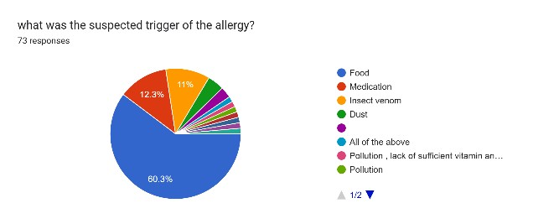
Skin rash (56.2%) was the most common first symptom, but many people also reported throat tightness and trouble breathing, which are signs of severe anaphylaxis.
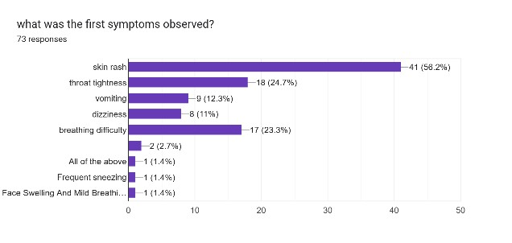
While 64.4% were aware of specific medications taken by an allergic individual, 35.6% were not informed about medical management. 58.9% said they would call a doctor in an emergency, but a small number said they would use home remedies. This shows that people don’t always know how to save lives correctly.
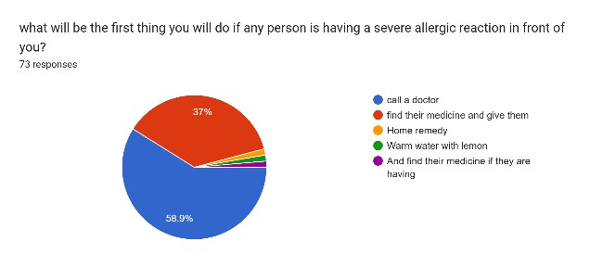

There was a lot of variation in what people knew about fatal triggers. For example, 76.7% knew that insect stings could kill someone, and half of the people who answered the question knew that anaesthesia could be a deadly allergen, followed by penicillin, ibuprofen and aspirin.
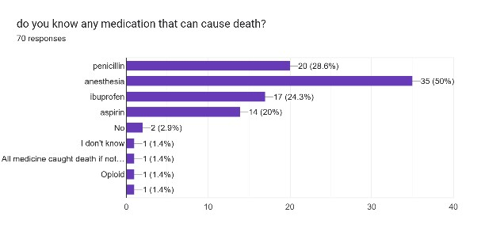
The most common food allergens that could kill you were seafood (45.1%), peanut butter (38%), and shellfish (33.8%). 67.1% of people had never personally experienced a deadly insect sting, but 32.9% knew someone who had.
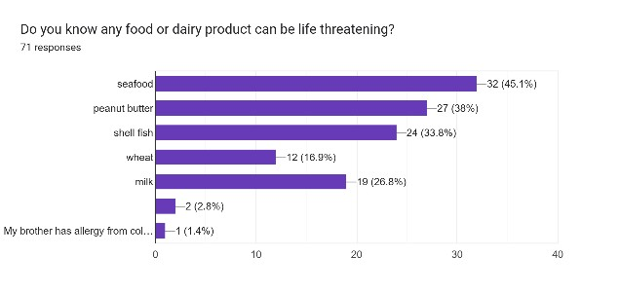
Most participants (80.3%) correctly identified the cause of death in anaphylaxis as accidental. But 12.7% thought it could be murder, which shows that they knew of rare cases where someone purposely exposed themselves to an allergen. Also, 13.7% said they knew people with allergies who had talked about wanting to kill themselves. This suggests that allergies that last a long time can affect your mental health.
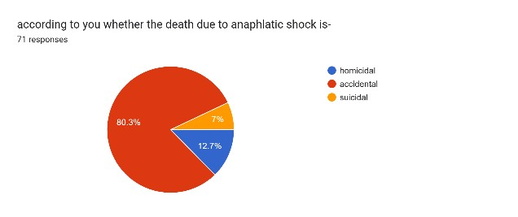

As related to the mechanism of death, only 43.7% correctly identified hypoxic respiratory arrest as the primary mechanism of death in anaphylactic shock, while others incorrectly identified the mechanism of death as uncontrolled asthma or general inflammation.
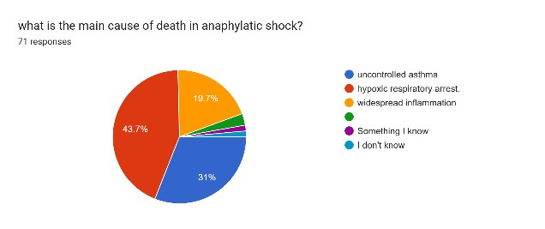
Altogether, these results indicate that there exists awareness of allergies, but misconceptions remain related to fatal triggers, acute care responses, and the pathophysiology of anaphylactic death. These gaps indicate that public education should be improved and have major implications for both medical management of anaphylaxis and forensically investigating suspected anaphylactic deaths.

Suggestions
The findings of the current research suggest a number of actions to promote public awareness, emergency response, and a better understanding of the medico-legal issues regarding anaphylactic shock:
- Public Awareness and Education Campaigns: Because a substantial amount of the survey participants had no awareness that life-threatening allergic reactions even existed, and also no understanding of the mechanism of those reactions, it stands to reason that there is an urgent need for organized awareness programs. Educational and awareness campaigns should be produced for dissemination through schools, colleges, hotels, and social media channels that address common allergens, recognizing warning signs, and recognizing that anaphylaxis is a serious allergic reaction requiring medical attention.
- Emergency Response Training: Several respondents were uncertain of what steps to take, or suggested home remedies. At the community level, there should be training on first aid with focused and specific knowledge about what to do in cases of anaphylaxis, including the use of epinephrine injectors. Coordinated training for teachers, students, and the parent or family of the anaphylactic person can prevent deaths from anaphylaxis.
- Wide Availability of Epinephrine Injectors: Since delayed involvements of the medical/hospital system are one of the prime causes of fatal anaphylaxis, policies should strive to make auto-injectors affordable, available, and public knowledge. Pharmacies, schools, public spaces, and workplaces should be incentivized to stock auto-injectors and emergency preparedness kits.
- Well-Defined Allergen Labels: Food products, cosmetics, and medications need clearer allergen labels to help protect against accidental exposure. Knowledge of common allergens, such as seafood, peanuts, milk and certain medications, should be improved.

- Improved Medical Counselling for HighRisk Individuals: Known allergy sufferers should be provided with proper medical counselling. They should be educated on triggers, prevention measures, and emergency procedures, as well as an individualized allergy action plans.
- Mental Health Support for Those with Chronic Allergies: Given that 13.7% of respondents indicated that they knew of individuals with allergies that disclosed suicidal ideations, psychological counselling and emotional support systems are necessary. Chronic allergies impact quality-of-life significantly and can contribute to anxiety, fear, and depression.
- Forensic Training and Standardized Guidelines: Since there were ambiguities regarding the manner of death (accidental, suicidal, or homicidal), forensic team members should adopt standardized protocols for the investigation of suspected anaphylactic death, and training on how to recognize injection marks, food particles, allergen trace residues, medications, and other environmental triggers should be implemented.
- Interdisciplinary Collaboration: Collaboration among allergists, emergency physicians, forensic pathologists, and medico-legal experts should be encouraged in order to enhance the diagnosis, documentation, and legal adjudication of cases related to anaphylaxis.

Conclusion
The anaphylactic is the rapid death due to lethal life threatening as it is a fatal outcome of anaphylaxis shock, this is an acute allergic reaction that can resultant into the death within in minutes if the injection that is the epinephrine or the adrenaline is not administered promptly. The main factors of anaphylactic death are due to the lacky of timely given injection that is adrenaline and epinephrine and because of delayed recognition or treatment.
While the avoidance of known allergens and through the proper systematic patient education is always important in the reduction of fatalities. Through the understanding of risk factor that will surely ensure in treatment is vital for addressing and managing the anaphylaxis death. The results of anaphylaxis are confirmed by the forensic pathologists they can confirm about the diagnosis through immunohistochemistry for the inflammatory indicators.
Therefore, by a successful investigation there require a high index of suspicion and the proper toxicological methods to draw a conclusion whether is the lethal immune reaction from the other forms of sudden death. Anaphylactic death reaction as to the food is generally occur to the children and adolescents. As result postmortem diagnosis is difficult and this is only possible when the all causes were excluded then it is taken into the consideration.

References

- Aravind Varman, M., Bannur, V., Nandhini Devi, S., & Dhivagar, K. (2025). Bee sting: Autopsy of an anaphylactic death—A case report. Journal of Forensic and Legal Medicine. [Advance online publication].
- Cingolani, M. (2021). Anaphylactic death: A new forensic workflow for diagnosis.
Diagnostics (Basel, Switzerland), 11(2), 263. https://doi.org/10.3390/diagnostics11020263
- Cleveland Clinic. (n.d.). Anaphylaxis. https://my.clevelandclinic.org/health/diseases/8619-anaphylaxis
- Del Duca, F., Manetti, A. C., Maiese, A., Napoletano, G., Ghamlouch, A., Pascale, N., Giorgio, B., Paola, F., & La Russa, R. (2023). Death due to anaphylactic reaction: The role of the forensic pathologist in an accurate postmortem diagnosis. Medicina, 59(12), 2184. https://doi.org/10.3390/medicina59122184
- Lindor, R. A., McMahon, E. M., Wood, J. P., Sadosty, A. T., Boie, E. T., & Campbell, R. L. (2014). Anaphylaxis-related malpractice lawsuits. The Journal of Allergy and Clinical Immunology, 133(4), 1212–1214. https://doi.org/10.1016/j.jaci.2013.11.025
- Mamun, R. (n.d.). Anaphylactic deaths: Causes & symptoms. Scribd. https://www.scribd.com/document/367726991/Anaphylactic-Deaths
- Mayo Clinic. (2023). Anaphylaxis. https://www.mayoclinic.org/diseasesconditions/anaphylaxis/symptoms-causes/syc-20351468
- Resuscitation Council UK. (2021). Emergency treatment of anaphylaxis: Guidelines for healthcare providers. https://www.resus.org.uk/sites/default/files/2021-
05/Emergency%20Treatment%20of%20Anaphylaxis%20May%202021_0.pdf
- Trani, N., Reggiani Bonetti, L., Gualandri, G., Barbolini, G., & Trani, M. (2012). Forensic investigation in anaphylactic deaths. In Forensic Medicine - From Old Problems to New Challenges. IntechOpen. https://doi.org/10.5772/25501
- Turner, P. J., Jerschow, E., Umasunthar, T., Lin, R., Campbell, D. E., & Boyle, R. J.
(2017). Fatal anaphylaxis: Mortality rate and risk factors. The Journal of Allergy and
Clinical Immunology: In Practice, 5(5), 1169–1178. https://doi.org/10.1016/j.jaip.2017.06.012
Correspondance address:

Author: Tiwari A*, LLM (forensic and criminal law) Address: Banasthali Vidyapith, Niwai , (304022) anushkatiwari12@gmail.com
Co-Author: Mangla V*, LLM (forensic and criminal law) vidhimangla08@gmail.com Kumari R*, LLM (forensic and criminal law) Address: Banasthali Vidyapith, Niwai , (304022) richisingh2102@gmail.com

