International Journal of Health Research
and Medico-Legal Practice
Copyright @ Dutta N, Kasàyap K, Edvina PK
ÏhiS iS üN Opeli-üCCeSS ürtiCle diStFibUted Under the Cfeüti¥e C0lïII+I0nS Attriàuti0n LiCenSe perI+IitS MnFeStriCted IJSe, diStFibUti0n ünd repF0diJCti0fl in üNy ITIediMI+I, pr0¥ided the Original
work is properly cited.
ORIGINAL RESEARCH PAPER
Parents' attitudes and l‹nowledge about adolescent physical and physiological changes
Dutta N¹, Kashyap H, Edvina PC

Address for correspondence 1Associate Professor (Corresponding author) Royal School of Nursing
IJHRMLP
ISSN 239—4 806X (Print), ISSN 2454—5159 (Online)
The Assam Royal Global University, Betkuchi, Guwahati-35,
Email: ndutta@rgu.ac Mobile: +917896183497
2Staﬀ Nurse
Nalbari Medical College and Hospital, Nalbari
Email: kashyapkrishangi@gmail.com Mobile: +918135890679
3Associate Professor
Krishna Nursing & Paramedical Institute, Lucknow. edvinaprincy@gmail.com Mobile: +919952175480

Received: 15-09-2025
Revised: 30-10-2025
Editorial approval: 31-10-2025 Checked for plagiarism: Yes Peer-reviewed article: Yes Editor approved:
32
Prof. Putul Mahanta
ABSTRAIT
Background and aims: Puberty-related health maintena nce and promotion is one of the most crucial educational issues and requires adequate knowledge. Adolescence experiences physical, psychological, and social changes during puberty. At the same time, parents’ understanding of this issue and related attitudes in early adolescents require information about bodily changes to prevent problems such as guilt and confusion. Thus, the current study investigated mothers’awareness ofthe health risks associated with puberty in their daughters. Methods: In this descriptive exploratory research design, 100 parents of adolescents (12-18 years) admitted to different wards and attending OPDs at 151 Base Hospital were selected using a random sampling method and surveyed using a researcher-developed questionnaire. The questionnaire's reliability was calculated using Cronbach's alpha, with tool II at 0.80 and tool III at 0.88. Results: Most parents (64%) had adequate knowledge, and a significant majority (87%) had a positive attitude towards adolescent physical and physiological changes. Knowledge and attitude showed a moderate positive correlation (r -— 0.013) with a mean score of 3.33, indicating that better knowledge is associated with a more positive attitude. Conclusion: The findings suggest that parents have a major influence on their adolescents’ understanding and experiences during this critical phase. By understanding parents’ perspectives, healthcare providers and educators can develop targeted interventions to support parents in guiding their adolescents through thèse changes, ultimately promoting healthy development and well-being.
Keywords: Parents; attitudes; knowledge; adolescents; physical and physiological changes.

Cite this article: Dutta N, Kashyap K, Edvina PK. Parents' attitudes and knowledge about adolescent physical and physiological changes. Int J Health Res Medico Leg Prae. 2025 July-Dec;11(2):32-37. Dot:

INTRODUCTION
Adolescence is one of the most charming and convoluted periods in the life span, a bridge between childhood and adulthood.' According to the World Health Organisation definition, adolescence covers the time between 10 and 19 years of age.' Adolescent population constitutes about 1.2 billion, and 85% of them
live in developing countries.' According to the report of the population and housing census (2011), 16.4% of Iran's population is within the 10—19 age group.’ People's future and fate are linked to making sensible choices and adjusting to the changes that occur during this stage of life.5 6 Physiological, biochemical, social, and psychological changes occur during puberty.7



This time frame serves as the foundation for adult life's infrastructure, and if it is not given the attention it needs, it can lead to several psychological issues, infectious diseases, unsuccessful marriages, and unsafe and early
pregnanciesg8
The study aims to assess the knowledge and attitude of parents regarding physical and physiological changes during adolescence in 151 Base Hospital, Basistha, Assam.
MATERIAL AND METHODS
A descriptive exploratory research design was conducted among the adolescent age group (12-18 years) admitted to different wards and attending 0PDs at 151 Base Hospital, using a random sampling method. Participants were included if they were available at the time of data collection and willing to participate. The data collection tools were structured questionnaires aligned with the study's objective. The tool was divided into three parts: Part I: Demographic data; Part II: Knowledge regarding physical and physiological changes during the adolescent period (semistructured questionnaires consisting of 11 items); and Part III: Attitude toward physical and physiological changes during the adolescent period (3-point Likert scale). These questionnaires were developed by thoroughly reviewing the relevant literature and were validated before the study. Reliability of the tool has been established, and the results show tool II at -0.80 and tool III at
-0.88. The study adopted a sample size of 100
parents. The study was conducted only after
approval from the IEC at the Army Institute of Nursing, Basistha. Formal permission was also obtained from 151 Base Hospital, Basistha, where the study was to be conducted. Confidentiality and Anonymity was maintained by securing all information provided by the respondents and ensuring that their information was not disclosed to anyone outside the research team. The data collected were collected, coded, classified, and tabulated. The data was entered into SPSS 20 for analysis. The data analysis used descriptive and inferential statistics.

RESULTS

Section A: Participants' demographics
IJHRMLP
ISSN 239—4 806X (Print), ISSN 2454—5159 (Online)
In this study, 100 parents of adolescents, of whom 49 (49%) are aged 45 years or more, have two children (58%), and physiological changes were observed at 14-15 years of age (35%). The majority, 45 (45%), belongs to a nuclear family having parents' educational status higher secondary, which includes 35(35%), occupation of either parent regular govt employee 61 (61%) with family income in Rs 31507 and above, i.e., 38 (38%) and residing
in an urban area 60 (60%).

Section B: Distribution of samples according to the knowledge level of parents regarding physical and physiological changes during adolescence

Table 1 Frequency distribution of the sample according to their level of knowledge of parents, N=100
33

Categories of knowledge score | Number of subjects | Percentage
Inadequate knowledge (1-4 score) | 3 | 3%
Average knowledge (5-7 score) | 33 | 33%
Adequate knowledge (8-10 score) | 64 | 64%

34

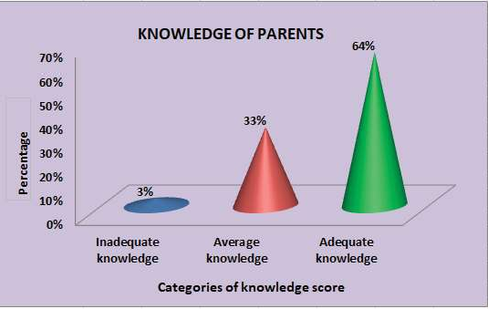
Figure 1 Conical diagram showing the percentage of knowledge of parents of adolescents The above Table 1 and Figure 1 show Section-C: Distribution of sample according
IJHRMLP
ISSN 239—4 806X (Print), ISSN 2454—5159 (Online)
that 64% of parents have adequate knowledge to the attitude level of parents regarding of physical and physiological changes, 33% physical and physiological changes during have average knowledge, and only 3% have adolescence
inadequate knowledge.
Table 2 Frequency distribution of the sample according to their level of attitude of parents regarding physical and physiological changes during Adolescence, N=100

Categories of attitude score | Number of subjects | Percentage
Positive attitude (30-33) | 87 | 87%
Neutral attitude (26-29) | 12 | 12%
Negative attitude (< 25) | 1 | 1%
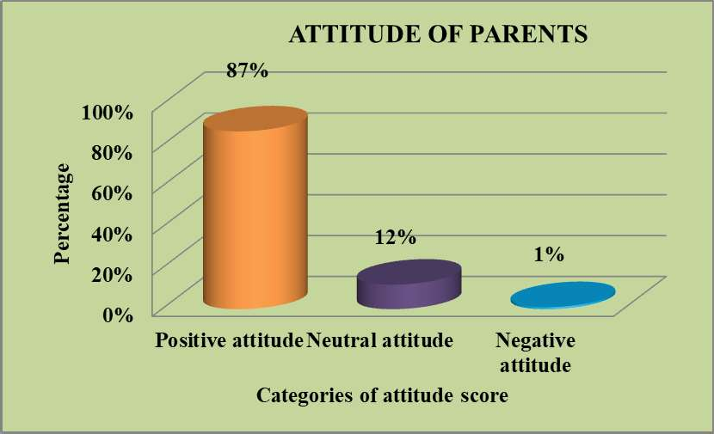
N=100
Figure 2 Cylindrical diagram showing the percentage of attitude of parents of adolescents

The above Table 2 and Figure 2 show that Section D: Correlation between knowledge 87% of parents have a positive attitude toward and attitude of parents regarding physical physical and physiological changes, 12% have an d p hys iolo gi c a1 cha nge s d uri ng a neutral attitude, and only 1% have a negative adolescence
attitude.
Table 3 Finding correlation between knowledge and attitude of parents regarding physical and physiological changes during Adolescence, N=100

Variables | Mean score | ’r’ value
Knowledge | 3.33 | 0.013
Attitude | 3.33 | 0.013
The data presented in the table shows highlighting a significant gap in awareness that there is a moderately positive correlation among most adolescent girls.’ A descriptive between knowledge and attitude among study conducted in Ludhiana, Punjab, by M Kaur parents, with a mean score of3.33, as evidenced found that 82% of adolescent girls had average by the r value of 0.013. Therefore, findings knowledge about pubertal changes, while 13% reveal that increased knowledge among parents had good knowledge. A small percentage (5%) about physical and physiological changes had below-average knowledge, indicating a in adolescents is associated with a positive need for targeted education and awareness attitude towards adolescents, and vice versa. programs.10 Similarly, a study conducted in
IJHRMLP
ISSN 239—4 806X (Print), ISSN 2454—5159 (Online)
Arunachal Pradesh by Mathew L and Rani B
DISCUSSIoN

Part I: Distribution of samples based on demographic data
found that most adolescent girls (55%) had average knowledge about pubertal changes. Additionally, 26.6% had good knowledge,

Thesurveyrevealedthat49% of parents are 16.7% had poor knowledge, and only a small over 45 years old, and 58% have two children. percentage (1.7%) had excellent knowledge, Notably, 35% of parents reported significant highlighting varying levels of awareness among physical and physiological changes in their the participants.1'

children at ages 14-15. Most parents (35%) were educated up to the higher secondary level, and their average family income was Rs 31,507 and above.

Part II: Parents' knowledge regardin
Part III: Parents' attitudes regarding physical and psychological changes during adolescence
The present study reveals that most

g parents (87%) exhibit a positive attitude
physical and physiological changes during towards physical and physiological changes

adolescence
in their children. Meanwhile, 12% of parents

The present study indicates that the display a neutral attitude, and a small minority majority (64%) of parents have adequate (1%) hold a negative attitude, indicating an knowledge regarding physical and physiological overall favourable outlook among parents.

changes, whereas 33% have average knowledge and only 3% have inadequate knowledge.
Similar studies have reported varying results on attitudes towards pubertal changes.

A similar study conducted in Tamil Nadu A study by Krishma, Sagar, and Mamta (2023)'2 by JL Prasad found that 33% of adolescent girls in Ludhiana, Punjab, found that 93.5% of early- had moderately adequate knowledge, while adolescent girls had a favourable attitude, while 6% had inadequate knowledge. Only 11% 6.5% had an unfavourable attitude. In contrast, of the girls possessed adequate knowledge, a study by Prajapati et a1. (2023)'3 in Eastern
35

Nepal found that 60.3% of respondents had a favourable attitude and 39.7% a moderately favourable attitude. These findings suggest that while many adolescents have a positive attitude towards pubertal changes, there is still room for improvement. Conducting educational classes and programs on menstruation and pubertal changes, and encouraging student involvement, could further enhance their attitudes and understanding.

Part IV: Correlation between knowledge and attitude of parents regarding physical and physiological changes during adolescence
The present study indicates a moderate positive corr elati on b etwe en p arents’ knowledge and attitude, with an ’r’ value of 0.01, suggesting that as parents’ knowledge of adolescents’ physical and physiological changes increases, their attitude towards them becomes more positive, and vice versa. A study by Krishma et al. (2023) investigated the correlation between knowledge and attitude, revealing a non-significant relationship (p = 0.09) with a correlation coefficient of r = 0.11. This suggests that there is no statistically significant correlation between knowledge and attitude, indicating that an increase in knowledge may not necessarily influence attitude in this context.'2 A study conducted by Rani M et a1., in two government schools of Ambala district found that the correlation coefficient (r) for pre-adolescent girls and boys was -0.178 and -0.025, respectively. The
IJHRMLP
ISSN 239—4 806X (Print), ISSN 2454—5159 (Online)
results indicated no significant correlation at the 0.05 level, suggesting that the variables under study were not significantly related to this population.“
Limitation: The sample consisted of parents who arrived at the hospital in the morning. The only days of the week when OPD was open were the alternate days. The findings may not apply to all parents, especially those from diverse cultural or socioeconomic backgrounds. The study may be constrained bya small sample size or insufficient representation from diverse socioeconomic, cultural, or geographical backgrounds.
CONCLUSION
This study highlights the crucial role parents play in adolescents' development. While many parents have basic knowledge of physical changes, there's a significant gap in understanding psychological and emotional aspects. This knowledge gap can strain parent- child relationships. Parents' attitudes directly impact their engagement, with supportive attitudes fostering open communication and healthier development. Targeted educational programs can enhance parental knowledge and promote positive attitudes, ultimately supporting adolescents' navigation of this critical phase.
Conflict of interest: The authors have none.
Acknowledgements: There is no conflict of interest among the authors.

36
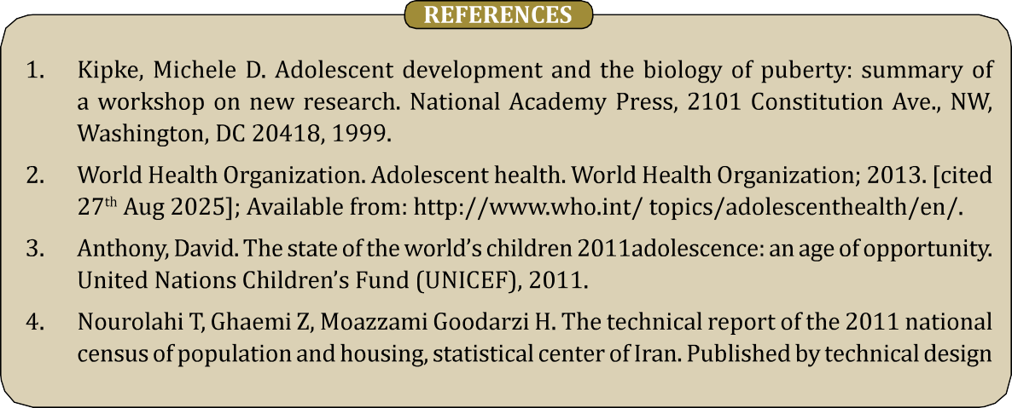

37

and statistical methods research group, 2013. [cited 27t' Aug 2025]; Available from: http:// www.amar.org.ir/Portals/1/Files/technical%20r.
- Weissman MM, Wolk S, Wickramaratne P, et al. Children with prepubertal-onset major depressive disorder and anxiety grown up. Arch Gen Psychiatry. 1999;56(9):794-801.
- Reynolds BM, Juvonen J. Pubertal timing fluctuations across middle school: implications for girls' psychological health. J Youth Adolesc. 2012;41(6):677-690.
- Ahangrzadeh Rezaei S, Khalilzadeh H. Enhancing management of mothers during adolescence of their daughters in guidance schools of Urmia. J Urmia Nurs Midwifery Fac. 2012;9(6):417- 23.
- Prasad JL, Abishek, Aishwariya, Ananthi, Cherian C, Banu R, et a1. A study to assess the knowledge on pubertal changes and menarche among adolescent girls residing in as selected rural community, Kanchipuram District, Tamil Nadu. Medico Legal Update. 2020;20(3):102-4.
IJHRMLP
ISSN 239—4 806X (Print), ISSN 2454—5159 (Online)
- Manjot Kaur. A descriptive study to assess the knowledge on pubertal changes during adolescence among girls studying in selected school of district Ludhiana, Punjab. [cited 27'h Aug 2025]; Available from: URL: http://nursing.journalspub.info/index. php?journal=ijwhn&page=article&op=view&path %5B%5D=481.
- Mathew L, Rani B. Assess the knowledge on pubertal changes among adolescent girls. The Research Reservoir of Paramedical Sciences. January - June 2021;7(1).
- Moodi M, Zamanipour N, Sharifirad GR, Shahnazi H. Evaluating puberty health program effect on knowledge increase among female intermediate and high school students in Birjand, Iran. J Educ Health Promot. 2013;2:57.
- Krishma, Sagar N, Mamta. A study to assess the knowledge and attitude regarding pubertal changes among early-adolescent girls. IJCRT 2023 April 11(4).
- Prajapati G, Tamang B, Pabina KC, Maharjan N, Rokaya RK. Magna Scientia Advanced Research and Reviews. 2023;08(01):38—45.
- Rani M, Sheoran P, Kumar Y. Knowledge and attitude regarding pubertal changes among pre-adolescents-a descriptive survey study. International Journal of Current Research. 2016;8(6):33697-702.

