CASE REPORT
Guided Bone Regeneration and Delayed Implant Placement
Medhi RK¹, Goswami D², Mahanta P³
¹Lecturer, Email: rakeshmedhi808@gmail.com, ²Professor and Head, Email: dr.goswami.dilip@gmail.com, Department of Periodontics and Oral Implantology, Regional Dental College and Hospital, Guwahati, Assam, India, 781032. 3Professor and Head, Department of Forensic Medicine and Toxicology, Nalbari Medical College and Hospital, Nalbari, Assam. Email: drpmahanta@gmail.com

ABSTRACT
A 33-year-old male patient with missing left maxillary anterior teeth underwent guided bone regeneration (GBR) using a titanium mesh and xenograft to prevent membrane collapse. First-stage GBR surgery was performed on day 1, followed by a second-stage surgery 5 months later for titanium mesh removal and implant placement. Prosthetic treatment was performed 3 months after the second stage surgery, and the implant showed good stability. The use of xenograft and titanium mesh is a promising and effective ridge-augmentation method for delayed implant placement.
Keywords: Ridge defect, guided bone regeneration, xenograft, titanium mesh, implant
INTRODUCTION
Guided Bone Regeneration (GBR) is the gold standard for bone regeneration, especially in atrophic ridges¹, and is recognised for its predictability in ridge augmentation. It involves creating a space around insufficient bone tissue using a membrane to promote cell migration and differentiation for bone formation.² The use of tissue adhesives may assist in maintaining shape during vertical bone augmentation. Non-resorbable membranes, such as expanded polytetrafluoroethylene (ePTFE), are favoured for their rigidity and facilitation of vascularisation.³ Titanium mesh, introduced by Boyne in 1969, is a preferred non-resorbable membrane for alveolar bone augmentation, known for its high strength, stability during wound healing, and adaptability to various defects.⁴
The timing of implant placement after GBR is flexible, as long as primary stability is achieved; however, a healing period is recommended for cases involving severe bone defects.⁵ This case report aims to demonstrate the use of a rigid titanium occlusive screwed barrier as a reliable alternative to guided bone regeneration, followed by the replacement of the missing incisor with an endosseous implant after a period of time.
CASE PRESENTATION
A 33-year-old man with a missing tooth number 22 and a broken tooth number 21, as shown in Figure 1, reported to the Department of Periodontics at Regional Dental College, Guwahati, Assam.
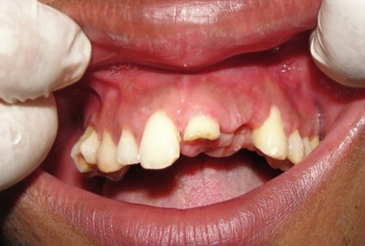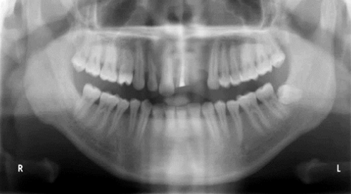
Figure 1: Fractured 21 and missing 22 in the maxilla with orthopantomogram evidence
A narrow maxillary ridge (Siebert class III ridge defect, 1983)⁶ with a severe horizontal and vertical bone defect (irt 22) and an Ellis class III fracture (irt 21) was detected after the clinical and radiographic evaluations. The orthopantomogram (OPG) showed an appropriate mesiodistal distance for dental implant placement. A Cone Beam Computed Tomography (CBCT) scan showed an insufficient alveolar ridge width for dental implant placement.
Before the procedure, the patient was informed of the full course of treatment and provided informed consent. Phase I therapy was completed, endodontic treatment was done on 21, and the necessary blood investigations were performed. The patient was found to be systemically healthy.
Following the administration of local anaesthesia (Xicaine, ICPA Healthcare Products Ltd.), a crestal incision and 2 vertical incisions were made on both sides of the surgical site. Thereafter, a full-thickness mucoperiosteal flap was elevated, as shown in Figure 2 (a & b).
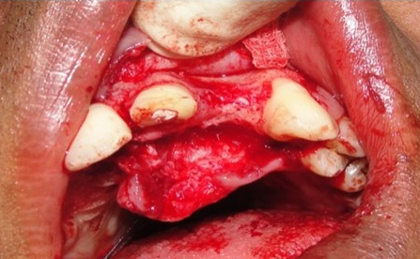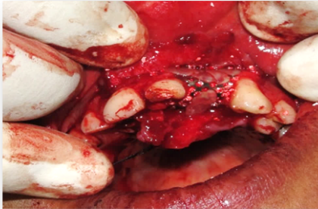
Figure 2: (a) Reflection of the mucoperiosteal flap, (b) Placement of bone graft
Following flap elevation, the area was curetted thoroughly. The alveolar ridge defect was visible; therefore, 0.5 cc of xenograft (Ti Oss, Obelis SA, South Korea) was used to fill the defect. To accomplish augmentation, the bone was shaped, and the defect site shape was maintained using titanium mesh (size 45 × 40 mm; thickness 1 mm, Wisdom Dental Products Pvt. Ltd., Mumbai), which was fixed at the bottom (anterior and posterior) with two bone tack tenting screws (size 1.4 × 4 mm, Wisdom Dental Products Pvt. Ltd., Mumbai), as shown in Figure 2 (c).
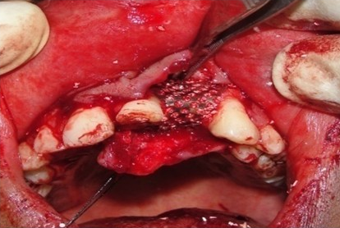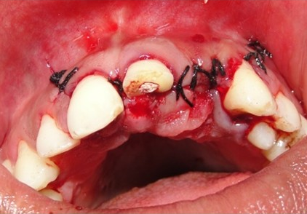
Figure 2: (c) Titanium mesh placed, (d) Suturing
The flaps were sutured with a 3‑0 silk suture (Ethicon, Division of Johnson and Johnson Ltd.). The patient was prescribed broad-spectrum antibiotics and analgesics and was also asked to maintain oral hygiene. The Intra-Oral Periapical radiograph (IOPA), taken after surgery, reveals the titanium mesh was in proper condition with intact screws.
After a 5-month healing period, the second stage of surgery was performed. Both sides had crestal and vertical incisions made, and the flaps were elevated, just as in the bone graft. A screwdriver (GBR-Kit IV) was used to remove the bone-tacking screws. The titanium mesh was carefully removed without affecting the grafted bone, as shown in Figure 3(a). Finally, sequential drilling was done, and an implant measuring 3.5 mm in diameter and 8.5 mm in length (TS III®; Osstem implant, Seoul, Korea) was used and placed in the osteotomy site, as shown in Figure 3(b). Adequate primary stability (35 N torque) was achieved. The healing abutment was placed on the same day.
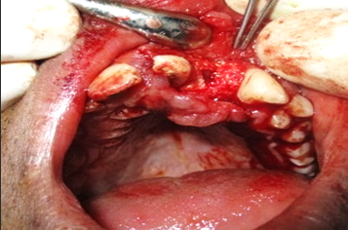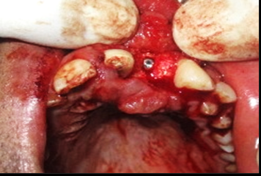
Figure 3: Second-stage surgery, (a) flap reflected and titanium mesh removed, (b) placement of an implant
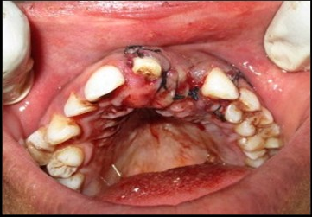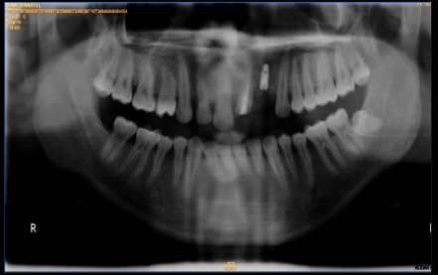
Figure 3: (c) Suture placed, (d) OPG
Prosthetic management was performed 3 months after implant placement. Following the second stage of surgery, the healing process was deemed to be satisfactory, and the healing abutment was surrounded by healthy gingival tissue. Furthermore, crown preparation was done for the endodontically treated tooth (21). Putty and light body (Avue gum by Avue) were used to create an open-tray impression on an Osstem mini open-tray impression coping. Finally, a screw-retained DMLS prosthesis was fabricated for 22 and fixed with a torque ratchet, and a DMLS crown was fabricated for 21, as shown in Figure 4(a-c).
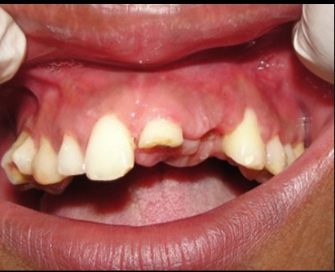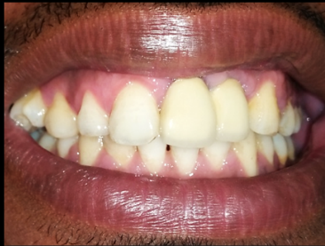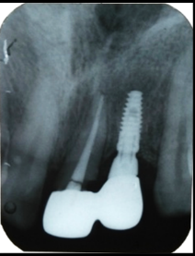
Figure 4 Prosthetic stage: (a) pre-op, (b) screw-retained DMLS crown placed, (c) intra-oral periapical view
DISCUSSION
IOPA view
PFM crown placed
Pre-op
In challenging cases of implant placement with insufficient bone support, bone augmentation techniques, particularly GBR with barrier membranes and bone grafts, have shown promising results.⁷ GBR is valued for its simplicity, low technical sensitivity, osteogenic stability, and ability for multidirectional osteogenesis, making it a preferred method for repairing alveolar bone defects. Notably, studies by Simion et al. and Jovanovic et al. utilised a titanium-reinforced (TR) membrane to enhance vertical bone regeneration without supportive substrates, resulting in supracrestal bone regeneration ranging from 3.3 mm to 1.82 mm. Recent findings⁸ indicate that combining a TR membrane with bone graft filler material provides more predictable outcomes for supracrestal bone formation, emphasising the importance of using autogenous bone grafts and non-resorbable membranes for advanced vertical bone reconstruction techniques.
In 2004, Roccuzzo et al.⁹ reported an average bone augmentation of 4.8 mm using titanium mesh for GBR on maxillary and mandibular bone defect sites. A subsequent 2007 study¹⁰ found that titanium mesh combined with bone graft significantly reduced bone resorption and complications compared with bone graft alone, highlighting its effectiveness in vertical bone augmentation for bone defects. In this case report, the authors used a rigid, non-resorbable membrane for bone augmentation and implant placement to improve GBR outcomes in severe ridge deficiency cases. The results demonstrated significant bone gain between preoperative and postoperative radiographs.
In this case study of GBR procedures, a titanium mesh non-resorbable barrier membrane was utilised. Bone grafts were categorised by origin as autografts, allografts, xenografts, or alloplasts. Type I collagen from bovine cortical bones was used to produce a xenogenic demineralised bone matrix (TiOss). After six months, the implant demonstrated satisfactory stability without significant biological complications.
Guided bone regeneration using a titanium occlusive screwed barrier alongside a bovine bone graft yields undeniable results. To enhance the effectiveness of titanium mesh biomaterials for dental applications, more research is needed to optimise pore sizes and spacing.
CONCLUSION
The use of a rigid titanium occlusive screwed barrier with bovine bone graft is a promising technique for GBR. This approach achieves an excellent final aesthetic outcome of the implant-supported restoration.
Acknowledgement: There is none to acknowledge.

Declaration of patient consent: The authors certify that they have obtained all appropriate patient consent forms. The form expresses the patient's consent for the journal to publish her images and other clinical information. The patient understands that the name and initial will not be published, and due efforts will be made to conceal identity, but anonymity cannot be guaranteed.

Financial support and sponsorship: None.

Conflicts of interest: None.

REFERENCES

1. Buser D, Dula K, Belser U, Hirt HP, Berthold H. Localized ridge augmentation using GBR, I. Surgical procedures in the maxilla. Int J Periodontics Restorative Dent. 1993; 13:29-45.

2. Hasegawa H, Masui S, Ishihata H, Kaneko T, Ishida D, Endo M, et al. Evaluation of a newly designed microperforated pure titanium membrane for guided bone regeneration. Int J Oral Maxillofac Implants. 2019 Mar/Apr;34(2):411-22.
3. Jung G, Jeon J, Hwang K, Park C. Preliminary evaluation of a three-dimensional, customized, and preformed titanium mesh in peri-implant alveolar bone regeneration. J Korean Assoc Oral Maxillofac Surg. 2014;40:181-7.
4. Elgali I, Omar O, Dahlin C, Thomsen P. Guided bone regeneration: materials and biological mechanisms revisited. Eur J Oral Sci. 2017;125:315–37.
5. Kim YK, Yun PY, Im JH, Hwang JW, Lee HJ. Implant installation after guided bone regeneration: comparison between immediate and delayed groups. J Korean Assoc Maxillofac Plast Reconstr Surg. 2007;29:333–9.
6. Seibert JS. Reconstruction of deformed, partially edentulous ridges, using full-thickness onlay grafts. Part 1. Technique and wound healing. Compend Cont Ed Gen Dent (Lawrenceville). 1983;4:437.
7. Buser D, Dula K, Hirt HP, Schenk RK. Lateral ridge augmentation using autograft and barrier membranes. A clinical study in 40 partially edentulous patients. Int J Oral Maxillofac Surg. 1996;54:420-32.
8. Simion M, Trisi P, Piattelli A. Vertical ridge augmentation using a membrane technique associated with osseointegrated implants. Int J Periodontics Restorative Dent. 1994;14:496-511.
9. Roccuzzo M, Ramieri G, Spada MC, Bianchi SD, Berrone S. Vertical alveolar ridge augmentation by means of a titanium mesh and autogenous bone grafts. Clin Oral Implants Res. 2004;15:73-81.
10. Roccuzzo M, Ramieri G, Bunino M, Berrone S. Autogenous bone graft alone or associated with titanium mesh for vertical alveolar ridge augmentation: a controlled clinical trial. Clin Oral Implants Res. 2007;18:286-94.

