Review article

BEYOND THE BOTTLE: A COMPREHENSIVE APPROACH TO TACKLING ALCOHOL ABUSE
Running title: Alcohol Abuse: A Comprehensive Review
ABSTRACT
Alcohol abuse represents a significant global health challenge with multifaceted ramifications spanning individual well-being, societal structures, and economic stability. This review synthesizes current literature to explore the intricate web of factors predisposing individuals to alcohol abuse, encompassing genetic predispositions, environmental influences, and psychological vulnerabilities. The consequences of alcohol abuse extend to various domains, including impaired cognitive function, diminished academic performance, and reduced economic productivity. Furthermore, the profound impact on mental health, characterized by increased rates of depression, anxiety, and suicidal ideation, necessitates a comprehensive understanding of the interplay between alcohol and psychological well-being. This article further examines the neurosurgical implications of alcohol abuse, highlighting the increased risk of traumatic brain injuries and the exacerbation of neurodegenerative conditions. In addressing this pervasive issue, a multi-pronged approach is essential, involving proactive measures by the general population, targeted interventions by psychiatrists and neurosurgeons, and comprehensive public health strategies. This review emphasizes the importance of early detection, evidence-based treatment modalities, and collaborative efforts to mitigate the detrimental effects of alcohol abuse and promote a healthier, more productive society.

Keywords: Alcohol abuse, addiction, education, mental health, public health, neurosurgery

Introduction
Alcohol abuse, a multifaceted global concern, engenders a wide spectrum of detrimental consequences that permeate various facets of human existence, encompassing public health, academics, socioeconomic stability, and even individual well-being. It is essential to recognize that while moderate alcohol consumption may be acceptable in certain social and cultural contexts, the excessive and uncontrolled intake of alcohol can lead to a myriad of adverse health outcomes and societal burdens.^{1,2,3} The World Health Organization estimates that alcohol use and misuse contribute to approximately 3.3 million deaths annually, representing 6% of all deaths worldwide.⁴ Alcohol misuse stands as a significant risk factor affecting population health globally, exerting a direct influence on numerous targets within the Sustainable Development Goals related to health, including those pertaining to mother and child health, infectious diseases, non communicable diseases, mental health and injuries.⁵ In 2016, alcohol misuse was linked to approximately 3 million deaths worldwide, along with 132.6 million disability-adjusted life years (DALY), constituting 5.1% of all DALYs for that year.⁶ It is estimated that 23.3% of Ghanaians consume alcohol, with 2.1% engaging in heavy drinking, and an annual per capita consumption of 20 liters. Alcohol abuse can lead to various physical and mental health problems, including liver disease, cardiovascular disorders, neurological damage, depression, anxiety, and increased risk of certain cancers.^{3,6,7} Furthermore, it can contribute to social issues such as domestic violence, child abuse, unemployment, and homelessness and thus becoming a leading cause of overall morbidity and mortality burden.^{8,9}

Predisposing Factors of Alcohol Abuse
The etiology of alcohol abuse is complex, involving a multifaceted interplay of genetic, environmental, and socio-economic factors that render certain individuals more susceptible than others (Figure 1).
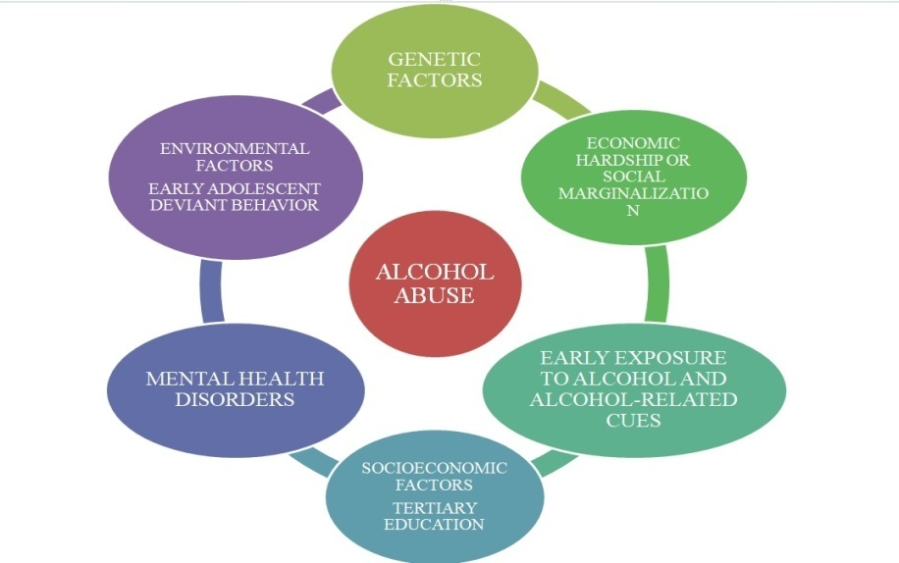
Figure 1: The various factors that interplay in alcohol abuse
Genetic predisposition is a significant factor, with individuals having a family history of alcoholism facing a higher risk of developing alcohol use disorders. Variations in genes related to alcohol metabolism, neurotransmitter function, and reward pathways have been linked to alcohol dependence. For instance, genes encoding alcohol dehydrogenase and aldehyde dehydrogenase enzymes, which are crucial in alcohol metabolism, have allelic variants influencing the rate of alcohol breakdown and acetaldehyde accumulation, affecting the risk of alcohol dependence. Genes involved in neurotransmitter systems, such as those encoding dopamine receptors (e.g., DRD2) and serotonin transporters (e.g., SLC6A4), also play a role by modulating reward and reinforcement pathways in the brain, influencing vulnerability to addiction.^{10,11} Environmental factors, encompassing an individual's upbringing, social environment, and exposure to alcohol-related cues, exert a profound influence on drinking behavior.¹¹ Early exposure to alcohol, whether through observing parents and close relatives or peer pressure, can significantly increase the likelihood of alcohol abuse later in life. Tertiary education, characterized by increased autonomy, academic pressures, and peer influence, can also be a predisposing factor. Socioeconomic factors, such as poverty, unemployment, and lack of educational opportunities, are intricately linked to alcohol abuse. People facing economic hardship or social marginalization may turn to alcohol as a means of coping with stress and adversity.⁹ Furthermore, the marketing and availability of alcohol, coupled with societal norms that promote its consumption, contribute to the overall prevalence of alcohol abuse within a community.¹² Mental health disorders, such as depression, anxiety, and post-traumatic stress disorder, frequently co-occur with alcohol abuse. Individuals grappling with these conditions may lean towards alcohol abuse as a let out, exacerbating both their mental health issues and their alcohol abuse. It is often comorbid with other substance abuse and psychiatric disorders. Genetic vulnerability to alcoholism may originate in personality or psychiatric traits that predispose to alcohol-seeking behavior, differential response to the effects of alcohol, or differential predisposition to addiction. Furthermore, earlier drinking initiation and an early onset of regular drinking represent risk factors for alcohol dependence.^{13,14} Childhood and early adolescent deviant behavior, family history of depression, and gender can also be significantly associated with alcohol abuse among students.¹⁵

Effects of Alcohol Abuse

A. Education
Alcohol abuse can have profound and far-reaching effects on education, hindering academic performance, diminishing cognitive function, and increasing the likelihood of school dropout. Students struggling with alcohol abuse often experience difficulties concentrating in class, remembering information, and completing assignments. Regardless of its impact in school completion, alcohol abuse could conceivably affect a student’s quality of learning and academic performance. Chronic alcohol use can lead to structural and functional changes in the brain, impairing memory, learning, and decision-making abilities.^{16,17} These deficits can significantly impede academic progress, limit educational attainment and may face disciplinary actions, such as suspension or expulsion, further disrupting their education.¹⁸ Moreover, it is frequently associated with increased absenteeism and tardiness, leading to missed learning opportunities and decreased academic engagement. College environments with heavy drinking cultures were more likely to have cases of abuse and dependence. Furthermore, research indicates that individuals who drop out of high school are at a significantly elevated risk of developing alcohol dependence later in life.¹⁹⁻²¹

B. Economics
The economic ramifications of alcohol abuse are substantial, impacting individuals, families, and society as a whole through decreased productivity, increased healthcare costs, and elevated rates of crime and violence. Individuals struggling with alcohol abuse often experience reduced work performance, absenteeism, and job loss. (Figure 2) Alcohol-related health problems, such as liver disease, heart disease, and certain cancers, place a significant burden on healthcare systems, diverting resources from other essential services.²² Alcohol abuse is frequently associated with increased rates of domestic violence, assault, and drunk driving, resulting in significant costs to the criminal justice system and society at large. Alcohol abuse can lead to financial instability, debt, and even homelessness, further exacerbating the economic burden on individuals and families.
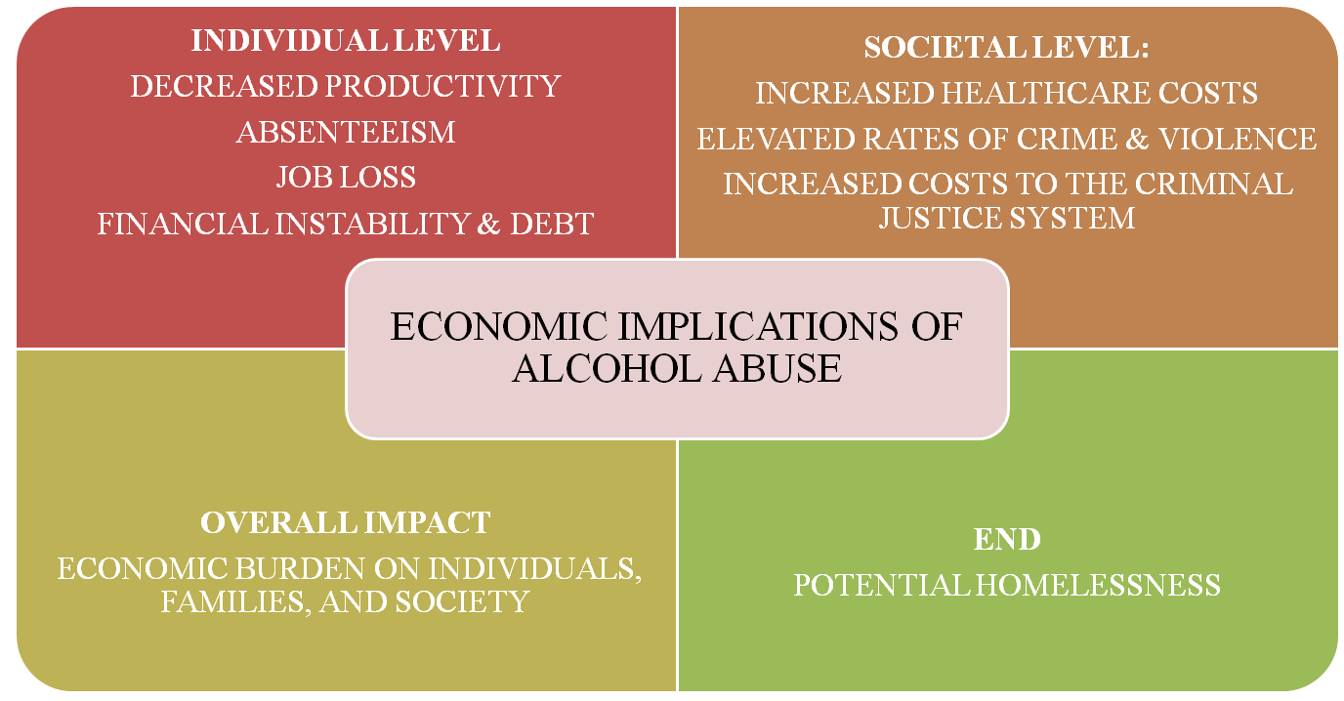
Figure 2: Relationship diagram showing the economic implications of alcohol abuse

C. Mental Health
Alcohol abuse and mental health disorders are intricately intertwined, with alcohol often serving as a maladaptive coping mechanism for individuals struggling with underlying psychological issues, thereby exacerbating both conditions. Alcohol can disrupt neurotransmitter function in the brain, leading to mood swings, anxiety, depression, and other mental health problems. Individuals with pre-existing mental health conditions may turn to alcohol as a form of self-medication, providing temporary relief from their symptoms but ultimately worsening their overall mental health.²³ Alcohol can also interfere with the effectiveness of mental health medications, complicating treatment efforts and prolonging recovery. Alcohol abuse has high lifetime comorbidity with psychiatric disorders. (Figure 3) It abuse is frequently associated with increased rates of suicide, self-harm, and other forms of destructive behavior. Long-term alcohol abuse can lead to the development of alcohol-induced psychosis, characterized by hallucinations, delusions, and disorganized thinking.²⁴
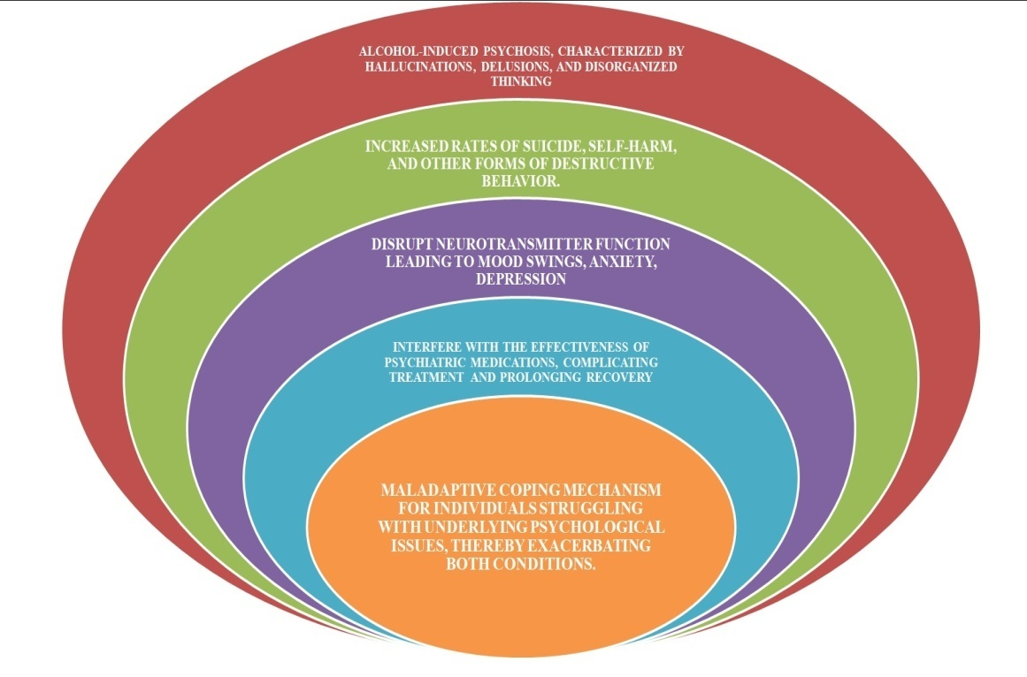
Figure 3: Mental health issues of alcohol abuse

Alcohol Abuse and Neurosurgery
Chronic alcohol abuse can significantly affect neurosurgical outcomes, increasing the risk of complications, prolonging recovery times, and exacerbating underlying neurological conditions. Alcohol abuse is also associated with increased risk of infections and respiratory failure.²⁵ Alcohol-induced liver damage can impair the ability to metabolize medications, requiring careful adjustments to anesthesia and pain management protocols during and after neurosurgical procedures. It also results in derangement of coagulation profile with an increased chance of intra operative bleeding. Keeping these in mind, there is a established protocol that we follow whenever a case with history of alcohol abuse presents to us in emergency. (Figure 4)
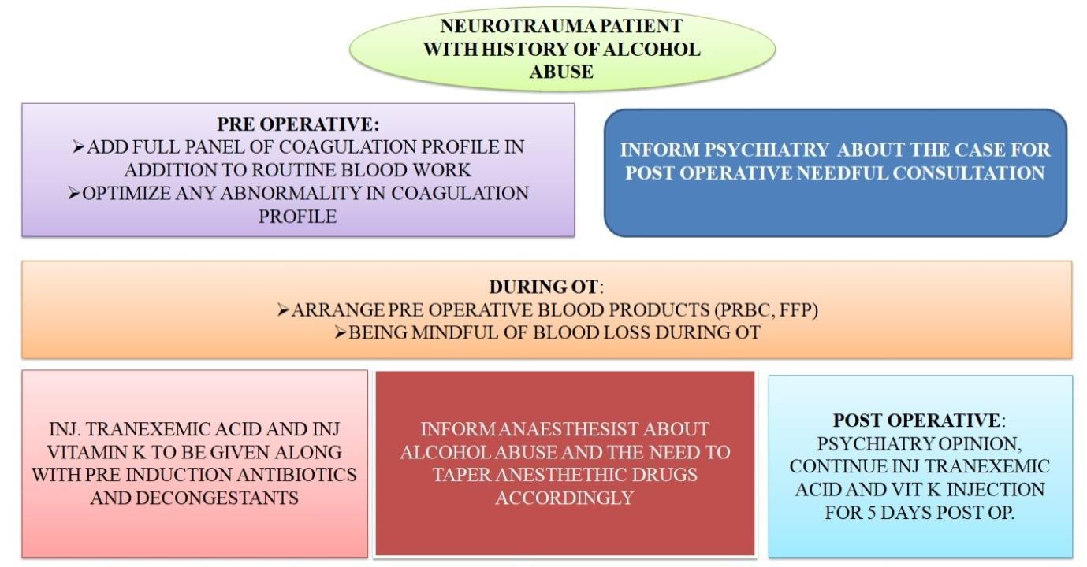
Figure 4: Protocol for management of cases with alcohol abuse in neurosurgery

The effects of alcohol on balance and coordination can increase the risk of falls and subsequent head injuries, requiring neurosurgical intervention. Alcohol withdrawal symptoms, such as seizures and delirium tremens, can pose significant challenges in the perioperative period, requiring careful monitoring and management. Alcohol abuse can also impair cognitive function and memory, affecting a patient's ability to follow post-operative instructions and participate in rehabilitation programs.^{25,26}

Addressing Alcohol Abuse

Recommendations for the General Population
To mitigate the detrimental effects of alcohol abuse on individuals and society, a multifaceted approach is essential, encompassing prevention, early intervention, and comprehensive treatment strategies, as well as broader societal initiatives to promote responsible alcohol consumption. Public health campaigns can raise awareness about the risks associated with alcohol abuse and promote responsible drinking habits, emphasizing moderation and the importance of avoiding binge drinking. Educational programs in schools and communities can equip individuals with the knowledge and skills to make informed decisions about alcohol consumption and to recognize the signs of alcohol abuse in themselves and others. Community-based support groups, such as Alcoholics Anonymous, can provide a safe and supportive environment for individuals struggling with alcohol abuse to share their experiences, build coping mechanisms, and maintain sobriety. Implementing stricter regulations on alcohol advertising and sales can help reduce the exposure of vulnerable populations, such as young people, to pro-alcohol messages and limit access to alcohol.²⁷

Role of Psychiatrists and Neurosurgeons
Psychiatrists and neurosurgeons play a crucial role in the identification, treatment, and management of alcohol abuse and its associated complications, working collaboratively to address both the underlying addiction and the neurological consequences. Psychiatrists can conduct thorough assessments to diagnose alcohol use disorders and co-occurring mental health conditions, developing individualized treatment plans that may include psychotherapy, medication, and support groups.²⁸ Neurosurgeons can provide specialized care for patients with alcohol-related neurological complications, such as traumatic brain injuries, subdural hematomas, and alcohol-induced cerebellar degeneration, employing surgical interventions and rehabilitation strategies to restore function and improve quality of life. Psychiatrists and neurosurgeons can educate patients and their families about the risks associated with alcohol abuse and the importance of adherence to treatment plans, promoting a collaborative approach to care. Furthermore, healthcare professionals are crucial in detecting health risks linked to alcohol use. Psychosocial and pharmacological therapies are essential for achieving and maintaining alcohol abstinence.²⁹⁻ ³¹

Strategies for Tackling Alcohol Abuse
Effective strategies for tackling alcohol abuse require a comprehensive approach that addresses individual, social, and environmental factors, promoting prevention, early intervention, and evidence-based treatment. Implementing and enforcing stricter alcohol control policies, such as raising taxes on alcohol, restricting advertising, and limiting the availability of alcohol, can reduce overall alcohol consumption and related harms. Expanding access to affordable and evidence-based treatment for alcohol use disorders, including behavioral therapies, medication-assisted treatment, and mutual support groups, can help individuals achieve and maintain sobriety.^{32, 33} Integrating alcohol screening and brief intervention into primary care and other healthcare settings can facilitate early identification and intervention for individuals at risk of developing alcohol use disorders. Promoting responsible alcohol consumption through public health campaigns, educational programs, and community-based initiatives can foster a culture of moderation and reduce the stigma associated with seeking help for alcohol-related problems.^{33, 34} Leaders can also implement strategies to address substance abuse among healthcare professionals, which ensures a safer environment for patients and employees. Early intervention and treatment can greatly improve outcomes for those struggling with alcohol dependence. Furthermore, ongoing support and care are crucial for maintaining abstinence, particularly in environments where alcohol use is prevalent.^{28, 35-38} A simple approach to reducing alcohol harms involves targeting heavy drinking through individual behavior and policy changes.

Conclusion
Alcohol abuse represents a significant public health challenge with far-reaching consequences for individuals, families, and society as a whole, impacting various aspects of life, including education, economics, mental health, and neurosurgical outcomes. A collaborative and integrated approach is crucial for mitigating the detrimental effects of alcohol abuse and promoting a healthier and more productive society, encompassing prevention, early intervention, comprehensive treatment, and ongoing support, as well as broader societal initiatives to foster responsible alcohol consumption. By implementing evidence-based strategies and working together, healthcare professionals, policymakers, and community members can make a meaningful difference in the lives of individuals affected by alcohol abuse. Screening and interventions can be effectively enhanced by integrating them into routine patient admission procedures. Furthermore, interventions should be culturally sensitive and tailored to the specific needs of different populations. Addressing alcohol abuse is essential for the well-being of both individuals and the community.

References
- Vicary JR, Karshin CM. College alcohol abuse: A review of the problems, issues, and prevention approaches. Journal of Primary Prevention. 2002 Mar;22(3):299-331.
- Uhl GR, Koob GF, Cable J. The neurobiology of addiction. Annals of the New York academy of sciences. 2019 Sep;1451(1):5-28.
- Health risks and benefits of alcohol consumption. PubMed. National Institutes of Health; 2000 Jan 1 [cited 2025 Apr];24(1):5. Available from: https://pubmed.ncbi.nlm.nih.gov/11199274
- Sudhinaraset M, Wigglesworth C, Takeuchi DT. Social and Cultural Contexts of Alcohol Use: Influences in a Social-Ecological Framework. PubMed. 2016 Jan 1 [cited 2025 May];38(1):35. Available from: https://pubmed.ncbi.nlm.nih.gov/27159810
- Rehm J. The risks associated with alcohol use and alcoholism. PubMed. 2011 Jan 1 [cited 2025 May];34(2):135. Available from: https://pubmed.ncbi.nlm.nih.gov/22330211
- Anyinzaam-Adolipore JN, Alhassan AR. Sociodemographic Correlates of Alcohol Abuse in Kassena-Nankana Municipality, Ghana. Journal of Addiction. 2020 Nov 5 [cited 2025 Apr];2020:1. Available from: https://doi.org/10.1155/2020/4375420
- Tian Y, Liu J, Zhao Y, Jiang N, Liu X, Zhao G, et al. Alcohol consumption and all-cause and cause-specific mortality among US adults: prospective cohort study. BMC Medicine. 2023 Jun 7 [cited 2025 Feb];21(1). Available from: https://doi.org/10.1186/s12916-023-02907-6
- Wyper GMA, Mackay D, Fraser C, Lewsey J, Robinson M, Beeston C, et al. Evaluating the impact of alcohol minimum unit pricing on deaths and hospitalisations in Scotland: a controlled interrupted time series study. The Lancet. 2023 Mar 21 [cited 2025 May];401(10385):1361. Available from: https://doi.org/10.1016/s0140-6736(23)00497-x
- Aboagye RG, Kugbey N, Ahinkorah BO, Seidu AA, Cadri A, Akonor PY. Alcohol consumption among tertiary students in the Hohoe municipality, Ghana: analysis of prevalence, effects, and associated factors from a cross-sectional study. BMC Psychiatry. 2021 Sep 3 [cited 2025 Apr];21(1). Available from: https://doi.org/10.1186/s12888-021-03447-0
- Bernardin F, Maheut-Bosser A, Paille F. Cognitive Impairments in Alcohol-Dependent Subjects. Frontiers in Psychiatry [Internet]. Frontiers Media; 2014 Jul 16 [cited 2025 May];5. Available from: https://doi.org/10.3389/fpsyt.2014.00078
- Molina PE, Gardner JD, Souza‐Smith FM, Whitaker AM. Alcohol Abuse: Critical Pathophysiological Processes and Contribution to Disease Burden. Physiology. American Physiological Society; 2014 May 1 [cited 2025 Apr];29(3):203. Available from: https://doi.org/10.1152/physiol.00055.2013
- Ampofo JA, Abrefi AA. The effect of alcoholism among the youth of zongo community of wa in the upper west region of ghana. International Journal of Management & Entrepreneurship Research. 2020 Oct 23 [cited 2025 Jan];2(5):314. Available from: https://doi.org/10.51594/ijmer.v2i5.165
- Enoch M, Goldman D. The genetics of alcoholism and alcohol abuse. Current Psychiatry Reports. Springer Science+Business Media; 2001 Apr 1 [cited 2025 Apr];3(2):144. Available from: https://doi.org/10.1007/s11920-001-0012-3
- Yeung EW, Spychala KM, Miller AP, Otto JM, Deak JD, Kim H, et al. Effects of genetic risk for alcohol dependence and onset of regular drinking on the progression to alcohol dependence: A polygenic risk score approach. Drug and Alcohol Dependence [Internet]. 2021 Oct 11 [cited 2025 Feb];230:109117. Available from: https://doi.org/10.1016/j.drugalcdep.2021.109117
- MacDonald R, Fleming MF, Barry KL. Risk Factors Associated with Alcohol Abuse in College Students. The American Journal of Drug and Alcohol Abuse. 1991 Jan 1 [cited 2025 Feb];17(4):439. Available from: https://doi.org/10.3109/00952999109001603
- Kyei‐Gyamfi S, Wellington N, Kyei‐Arthur F. Prevalence, Reasons, Predictors, Perceived Effects, and Regulation of Alcohol Use among Children in Ghana. Journal of Addiction. 2023 Jul 18 [cited 2025 May];2023:1. Available from: https://doi.org/10.1155/2023/9032348
- Balsa AI, Giuliano L, French MT. The effects of alcohol use on academic achievement in high school. Economics of Education Review. 2010 Jul 7 [cited 2025 Feb];30(1):1. Available from: https://doi.org/10.1016/j.econedurev.2010.06.015
- Kamalu NC. Binge Drinking Among College Students: Trends, Consequences and Possible Solutions. Sumerianz Journal of Social Science. 2023 Feb 16 [cited 2025 Apr];(61):11. Available from: https://doi.org/10.47752/sjss.61.11.19
- Arria AM, Garnier-Dykstra LM, Caldeira KM, Vincent KB, Winick ER, O’Grady KE. Drug Use Patterns and Continuous Enrollment in College:Results From a Longitudinal Study. Journal of Studies on Alcohol and Drugs . 2013 Jan 1 [cited 2025 Feb];74(1):71. Available from: https://doi.org/10.15288/jsad.2013.74.71
- Knight JR, Wechsler H, Mohler‐Kuo M, Seibring M, Weitzman ER, Schuckit MA. Alcohol abuse and dependence among U.S. college students. Journal of Studies on Alcohol. 2002 May 1 [cited 2025 Feb];63(3):263. Available from: https://doi.org/10.15288/jsa.2002.63.263
- Harford TC, Yi H, Hilton ME. Alcohol Abuse and Dependence in College and Noncollege Samples: A Ten-Year Prospective Follow-Up in a National Survey. Journal of Studies on Alcohol. 2006 Nov 1 [cited 2025 Feb];67(6):803. Available from: https://doi.org/10.15288/jsa.2006.67.803
- Gmel G, Rehm J. Harmful alcohol use. PubMed. National Institutes of Health; 2003 Jan 1 [cited 2025 Apr];27(1):52. Available from: https://pubmed.ncbi.nlm.nih.gov/15301400
- Pearl AM, Kwarteng OMJ, Krafona K, Ekem‐Ferguson G. Predictive Role of Duration of Treatment, Social Anxiety in Self-Efficacy to Resist Alcohol among Persons with Alcohol Use Disorder in Ghana. International Archives of Substance Abuse and Rehabilitation. 2022 Feb 7 [cited 2025 Feb];4(1). Available from: https://doi.org/10.23937/2690-263x/1710012
- Al-Maqbali JS, Al-Maqrashi N, Al-Huraizi A, Al-Maamari Q, Alawi KA, Alawi AMA. Clinical characteristics and health outcomes in patients with alcohol withdrawal syndrome: an observational study from Oman. Annals of Saudi Medicine. 2022 Jan 1 [cited 2025 Apr];42(1):52. Available from: https://doi.org/10.5144/0256-4947.2022.52
- Jurkovich G. The Effect of Acute Alcohol Intoxication and Chronic Alcohol Abuse on Outcome From Trauma. JAMA. 1993 Jul 7 [cited 2025 Apr];270(1):51. Available from: https://doi.org/10.1001/jama.1993.03510010057029
- Ezquer F, Morales P, Quintanilla ME, Santapau D, Lespay‐Rebolledo C, Ezquer M, et al. Intravenous administration of anti-inflammatory mesenchymal stem cell spheroids reduces chronic alcohol intake and abolishes binge-drinking. Scientific Reports. 2018 Mar 6 [cited 2025 Feb];8(1). Available from: https://doi.org/10.1038/s41598-018-22750-7
- Harper C. The Neuropathology of Alcohol-Related Brain Damage. Alcohol and Alcoholism. Oxford University Press; 2009 Jan 16 [cited 2025 Feb];44(2):136. Available from: https://doi.org/10.1093/alcalc/agn102
- Berglund M, Thelander S, Salaspuro M, Franck J, Andréasson S, Öjehagen A. Treatment of Alcohol Abuse: An Evidence‐Based Review. Alcoholism Clinical and Experimental Research. 2003 Oct 1 [cited 2025 Apr];27(10):1645. Available from: https://doi.org/10.1097/01.alc.0000090144.99832.19
- Booker M. Complications of Alcohol Use. InnovAiT Education and inspiration for general practice [Internet]. 2011 Jul 8 [cited 2025 Jan];4(11):651. Available from: https://doi.org/10.1093/innovait/inr098
- Hakala T, Kylmä J, Mäkelä K, Noppari E, Koivunen M. Caring for alcohol‐intoxicated patients in an emergency department from the nurses’ point of view – focus on attitudes and skills. Scandinavian Journal of Caring Sciences. 2020 Feb 9 [cited 2025 Apr];35(1):115. Available from: https://doi.org/10.1111/scs.12825
- Awan H, Vergis N. Psychosocial and Pharmacological Therapies to Reduce Alcohol Consumption in Severe Alcohol-Related Hepatitis Patients: A Case Report. Cureus. 2023 Apr 11 [cited 2025 Jan]; Available from: https://doi.org/10.7759/cureus.37443
- Parry C. A review of policy-relevant strategies and interventions to address the burden of alcohol on individuals and society in South Africa: original article. African Journal of Psychiatry. OMICS Publishing Group; 2005 Feb 25 [cited 2025 Feb];8(1). Available from: https://doi.org/10.4314/ajpsy.v8i1.30180
- O’Farrell TJ, Langenbucher J. Inpatient treatment of alcoholism: A behavioral approach. Journal of Substance Abuse Treatment. 1987 Jan 1 [cited 2025 Feb];4:215. Available from: https://doi.org/10.1016/s0740-5472(87)80016-8
- Miller NS, Gold MS. Management of withdrawal syndromes and relapse prevention in drug and alcohol dependence. PubMed. 1998 Jul 1 [cited 2025 Feb];58(1):139. Available from: https://pubmed.ncbi.nlm.nih.gov/9672434
- Smith AM, Campbell DG. Strategies to Address Substance-Abusing and Substance-Impaired Healthcare Professionals. International Journal of Applied Management and Technology. 2020 Jun 2 [cited 2025 Feb];19(1). Available from: https://doi.org/10.5590/ijamt.2020.19.1.08
- Pace CA, Uebelacker LA. Addressing Unhealthy Substance Use in Primary Care. Medical Clinics of North America. Elsevier BV; 2018 Jun 19 [cited 2025 Feb];102(4):567. Available from: https://doi.org/10.1016/j.mcna.2018.02.004
- Serebro B. Compliance in the Treatment of Alcohol-Dependent Individuals (Alcoholics). Journal of International Medical Research. 1979 May 1 [cited 2025 Feb];7(3):165. Available from: https://doi.org/10.1177/030006057900700301
- Nutt D, Rehm J. Doing it by numbers: A simple approach to reducing the harms of alcohol. Journal of Psychopharmacology. 2014 Jan 1 [cited 2025 Jan];28(1):3. Available from: https://doi.org/10.1177/0269881113512038

