COMMENTARY
Skeletal examination and post-mortem interval
Sujay VK¹, Prateek Rastogi²
Address for correspondence:
¹Senior Resident, ²Professor (Corresponding author)
Department of Forensic Medicine and Toxicology,
Kasturba Medical College
Mangalore, Manipal Academy of Higher Education, Manipal, India
Email: prateekrastogi1978@gmail.com
Mobile: +919448501376

Cite this article: Sujay VK, Prateek Rastogi. Skeletal examination and post-mortem interval. Int J Health Res Medico Leg Prae 2026 Jan-June;12(1):x-y. Doi:
INTRODUCTION
Skeletal remains analysis is a crucial science combining forensic osteology and forensic anthropology. The skeletal examination is conducted by the forensic medicine department upon receipt of a requisition from the police.¹ The police either bring the bundle of bones in a sealed manner or escort the forensic expert to the crime scene. This is to help the administration provide and maintain justice.
The administration, during the investigation of the alleged crime, requires answers to certain questions, and this paper aims to discuss the possible ways the time since death (post-mortem interval) can be estimated from skeletal remains.²
The post-mortem interval is defined as the length of time between the time of the victim's death and the time at which examination of the discovered body is done. Skeletal examination is conducted to gather information about the unknown skeletal remains, revealing details about the individuals who disposed of the victim's body and addressing unanswered questions related to mass graves from war zones, natural disasters, and other circumstances involving discovered skeletal remains. The investigative agencies need identification of the bones found and an opinion regarding the sex, age, height, cause of death, and time since death of the victims whose skeletal remains were discovered.³
The concerned police bring skeletal remains and request the forensic experts to provide them with details regarding the nature of the skeleton, sex, height of the victim, opinion regarding the cause of death, and time since death. The anatomical knowledge of bones and the physiological changes that occur throughout life form the basis for answering the questions posed by the investigating officer. The bag containing the bundle of bones is first checked for seals and labelling and compared with the sample seal and description provided with the requisition. The bones are then placed in anatomical order (Figure 1), and each bone is examined.
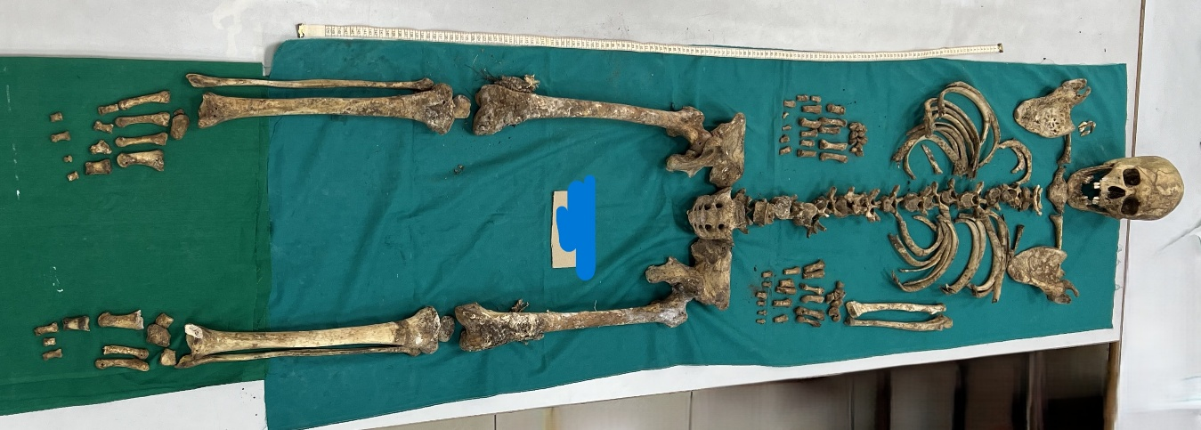
Figure 1 Skeletal remains in anatomical alignment
The above photo shows one case in which bones found were subjected to forensic examination, and, based on anatomical features, bone articulation, and morphological dimensions, all the bones examined were certified as belonging to a human male and to a single individual. The height, based on long-bone measurements, was estimated to be 165-170 cm. Based on cranial suture fusion, the age is estimated to be between 40 and 50 years. The post-mortem interval was estimated to be less than 6 months.
DISCUSSION
The bones are first kept in order, and all are identified. The colour of the bones and their morphological features, including length, breadth, and girth, are noted, as is the presence of cartilage or any other tissue. During decomposition, the soft tissues get removed first, leaving the skeleton intact. The forces of nature act on the dead body, causing decomposition and its removal.
When a dead body is on the surface of the ground, it is accessible to air, insects, and other animals. Both aerobic and anaerobic bacteria, fungi, and viruses destroy soft tissues. Animals will eat the flesh and nibble/gnaw at the bones. When the body is underground or covered by a layer of mud, roots from surrounding vegetation will grow into it and take nutrients for plant growth. The nature of Earth, such as its pH (acidity/alkalinity), water content, soil type, temperature, and insect and animal activity, influences the rate of decomposition. An accurate assessment of the post-mortem interval is difficult due to the various forces acting on the body. The longer the time since death, the more imprecise the estimated PMI becomes.¹⁻³
Structurally, the bone cells are called osteocytes. The bone contains organic and inorganic matter as its structural components. The extracellular matrix contains an inorganic component, comprising mainly hydroxyapatite crystals. The organic part has proteins such as albumin and haemoglobin, lipids, collagen, proteoglycans, and water. Some of the methods used for estimating the PMI are the following:
Radiocarbon (C14) Dating: It can be used to date organic materials because living organisms absorb and store 14C, an isotope of elemental carbon. Upon death, 14C begins to decay gradually with no assimilation in the body. However, because bones have lower carbon turnover and environmental variation in 14C concentrations, they cannot be used for accurate PMI estimation.
Other radioisotopes, 90Sr (Strontium), 210Po (Polonium), and 228Ra (Radium), and their decay product, 228Th (Thorium), have been tested in human bones but have yielded results similar to those obtained with 14C. The ratio of 228Ra/228Th is independent of external factors, depends on the ingestion of 228Ra, and holds promise for providing the most promising results in the estimation of PMI.⁴⁻⁶
Fluorescence techniques, such as luminol and ultraviolet-induced light, offer the advantages of being cheaper and faster than C14 dating. Luminol is widely used in crime scene investigations to detect blood. It is a chemical compound that emits blue fluorescence in the presence of an activating factor (haemoglobin). Similarly, the UV light fluorescence method is used by observing the width of the reflecting surface from the sample of bone, with a larger area indicating a smaller PMI.^{7,8}
Proteomics: The study of proteins. Protein content of bones degrades in multiple ways, including deamidation or hydrolysis. Environmental temperature influences protein degradation, with rapid degradation at higher temperatures. Some proteins, viz., alpha-1-antitrypsin and chromogranin A, show increased concentrations with biological age. Prieto-Bonete et al. proposed a profile of 32 proteins for analysing bones with a PMI of 12 years or more.^{9,10}
Evaluation of bone components: MicroRNA, DNA concentration, and collagen degradation
Hagelberg et al¹¹ have shown that DNA degradation and PMI are not correlated. It is affected by how bone is preserved in the environment, such as soil composition. Jellinghaus et al¹² used a method to measure the ratio of collagenous to non-collagenous protein and have demonstrated that a significant decrease in this ratio correlates with PMI for males. Joo-Young Na¹³ conducted a study on the use of microRNA in bones to determine PMI for up to 2 years, but a negative correlation was observed.
Raman spectroscopy: The advantage is that it is microscopic, fast, and nondestructive. The device is portable. It can be used to detect the collagen and mineral phases that are present in the extracellular matrix. Based on the CH-aliphatic ratio, which is a ratio that represents the organic-to-mineral content, it is the amount of lipids and other organic materials in bone.¹⁴ But changes in the organic and inorganic components of bone (or their ratio) have not been linked to PMI.
CONCLUSION
The primary challenge in estimating PMI in skeletal remains is the lack of consistent, reliable markers suitable for forensic purposes. The choice of methods depends on the circumstances in each case and the available resources.
Recommendation: Further advancements and research in the field of forensic science are necessary to improve the precision of the estimation of PMI. Further investment in research and the development of methodologies is necessary to estimate the late PMI. Cooperation between forensic medicine experts and forensic science teams should be encouraged to ensure the highest quality of criminal investigation through accurate, precise evaluation.^{15,16}
REFERENCES
1. Reddy KS, Murty OP. Essentials of forensic medicine and toxicology. 35th ed. New Delhi: Jaypee Brothers Medical Publishers; 2022. p. 94–96.
2. Aggrawal A. Textbook of forensic medicine. 2nd ed. Reprint 2022. New Delhi: Avichal Publishing Company; 2022. p. 152–158.
3. Chand S. Forensic osteology. In: Chand S, editor. Essentials of forensic medicine and toxicology. 3rd ed. New Delhi: Elsevier Health Sciences; 2025. p. 224–229.
4. Swift B, Lauder I, Black S, Norris J. An estimation of the post-mortem interval in human skeletal remains: a radionuclide and trace element approach. Forensic Sci Int. 2001 Mar 1;117(1-2):73–87.
5. Ashrafkhani B, Tabesh A, Tamsen F, et al. A novel method for assessing post-mortem interval using radon radioisotopic decay – an internal radon time of death clock'. Sci Rep. 2025;15:29149.
6. Ubelaker DH. Radiocarbon analysis of human remains: a review of forensic applications. J Forensic Sci. 2014;59(6):1466–1472.
7. Estracanholli ÉS, Kurachi C, Vicente JR, Menezes PFC, Silva Júnior OC, Bagnato VS Determination of post-mortem interval using in situ tissue optical fluorescence. Opt Express. 2009;17(10):8185–92.
8. Ermida C, Cunha E, Ferreira MT. Dating death: post-mortem interval estimation of human skeletal remains. Antropol Port. 2022;39:45–72.
9. Marrone A, La Russa D, Barberio L, Murfuni MS, Gaspari M, Pellegrino D. Forensic proteomics for the discovery of new post-mortem interval biomarkers: a preliminary study. Int J Mol Sci. 2023;24:14627.
10. Prieto-Bonete G, Pérez-Cárceles, Maurandi-López A, Pérez-Martínez C, Luna A. Association between protein profile and post-mortem interval in human bone remains. J Proteom. 2019;192:54–63.
11. Hagelberg E, Bell LS, Allen T, Boyde A, Jones SJ, Clegg JB. Analysis of ancient bone DNA: techniques and applications. Philos Trans R Soc B Biol Sci. 1991;333:399–407.
12. Jellinghaus K, Urban PK, Hachmann C, Bohnert M, Hotz G, Rosendahl W, et al. Collagen degradation as a possibility to determine the post-mortem interval (PMI) of human bones in a forensic context—a survey. Leg Med (Tokyo). 2019;36:96–102.
13. Na JY. Estimation of the post-mortem interval using microRNA in the bones. J Forensic Leg Med. 2020;75:102049.
14. Woess C, Huck CW, Badzoka J, Kappacher C, Arora R, Lindtner RA, et al. Raman spectroscopy for post-mortem interval estimation of human skeletal remains: a scoping review. J Biophotonics. 2023;16(10):e202300189.
15. Franceschetti L, Amadasi A, Bugelli V, Bolsi G, Tsokos M. Estimation of late post-mortem interval: where do we stand? a literature review. Biology (Basel). 2023;12:783.
16. Villa C, Lynnerup N. Age estimation of skeletal remains: principal methods. Res Rep Forensic Med Sci. 2014;3-9.
15. Franceschetti L, Amadasi A, Bugelli V, Bolsi G, Tsokos M. Estimation of late post-mortem interval: where do we stand? A literature review. Biology (Basel). 2023;12:783.
16. Villa C, Lynnerup N. Age estimation of skeletal remains: principal methods. Res Rep Forensic Med Sci. 2014;3-9.

