From Bones to Justice: Medico - Legal of Forensic Anthropology
Gautam.A; Rathi.K; Sahlot.K
ABSTRACT
Anthropology is identification of human remains by using scientific study. It mainly applies in criminal cases, accidental, war cases ,mass disaster victims etc. where it becomes difficult to identify the human body by dependent bones. This is method of science and evolved from time to time. Sometimes it becomes difficult to analysis the human remains as it's not found on the same place or either due to less technology There are various ways to identify the body when it is doubtful about gender, age etc. Anthropologists identify it by using scientific methods including skeletal analysis, facial reconstruction, dental identification and DNA profiling.
Keywords: DNA Profiling, Facial Construction, Human Identification, Human Skeletal
Methodology
This research is based on both Doctrinal and Non–Doctrinal methods.
Introduction
Anthropology means the examination of unknown human skeletal by ascertaining the sex, age, stature and estimate the time since death. This kind of examination helps to recognize the individual and its injuries, and the study plays a vital role as evidentiary value in courts. The techniques used here will be applicable as medico legal importance of it.
Márquez-Grant & Robert, 2021 laid down the definition of forensic anthropology as "the study of human using biological, social& cultural anthropology to assist with the identification of the living and dead, the recovery and repatriation of the deceased, and the interpretation of circumstances surrounding death.
Anthropologist uses the knowledge for identification of humans by bone size and shape and other factor of influence such properties. This study helps to form opinion in the court as expert.
History:
The history of forensic anthropology starts when some famous anthropologist worked through their research. During 1878, Thomas Dwight, a professor who published an essay on ‘The Identification of Human Skeleton’ and medico- legal study as well as he mentioned other aspects of identification that is estimation of sex, age, stature in his journal. Identification by Bertillon system was developed for the measurement of physical body parts. Majorly include the body parts and mainly focus on the head and face features. This concept was introduced by Alphonse Bertillon in 1879.This system involved physical estimation like measurement of body part, photograph of front and side head profile. In between 1887 to 1954, another anthropologist known as Ernest A. Hooton, is renowned for study forensic anthropology and his primary research was based on human variety, origin, adaption as well human evolution. T. Wingate Todd in 1885- 1938 who plays an important role in formation of path in forensic anthropology and has keen interest regarding the procedure of bone ageing and in addition to the growth of bone in adults and childhood age.
First microscopic study was published in 1964 regarding changes in human body associated with age by N. Bathazard. In 1962, kerogman publish the research on the techniques use for facial recognition name as ‘The Human Skelton in Forensic Medicine’. In 1972, there was establishment of the Physical Anthropology section of the American academy of forensic science (AAFS) which helped in development and enhanced the field of forensic anthropology in detail. There was scientific working group for forensic anthropology that was established. This contains data bank which collects the information on documented forensic cases and still they are working on it. FBI has now provided the services to study forensic anthropology in human remain in medico- legal context.
Methods of human identification:
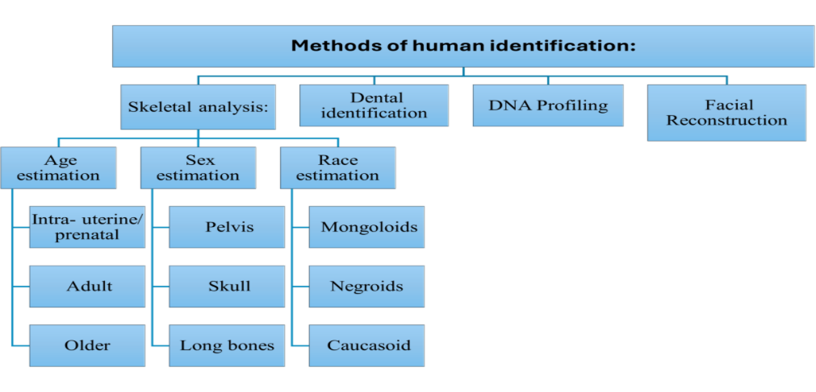Table-1
In Skeletal analysis, Human skeleton preserves essential biological records, retaining structural and morphological information long after the decomposition of shot tissues. Through Skeletal analysis, forensic anthropologists are able to reconstruct the biological profile of an individual. There are some important elements of Skeletal identification, which are Age estimation, Sex estimation, Race estimation. Dental identification is also a important method in forensic anthropology for identifying the identity of unknown human remains. Teeth are the most durable structure in human body and often survive decomposition, fire and other conditions which destroy soft tissues. Every individual exhibits a unique set of dental features, including tooth morphology, restorations, feelings, crown, extractions and wear patterns which can be compared with ante- mortem records for identification or to establish identity. DNA profiling examines the genetics of an individual. DNA can be extracted from bones, teeth, hair, blood or other biological tissues, even in the decomposed or burned or buried body. Forensic anthropologists collaborate with biologists to analyze DNA for direct individual identification. DNA profiling has transformed forensic anthropology by providing highly reliable evidence for human identification. Its application includes criminal investigations, mass disaster victim identification, missing person cases and human rights inquiries. Facial reconstruction is a forensic method used to approximate the appearance of an individual from their skeleton, particularly the skull when other identification methods fail. It combines principles of anatomy, anthropology and artistic modeling to recreate facial features facilitating investigators with a visual approximation for potential recognition by relatives or the public. The use of facial reconstruction along with the digital records DNA analysis and skeleton profiling enhance the accuracy and effectiveness of human identification.
Role of Forensic Anthropology in Investigation:
Forensic anthropology is a important concept within forensic science, its primarily role is to establish the identity of unknown individual and provide information about the reason of their death. Forensic anthropologists primarily focus on biological profile reconstruction, estimating postmortem intervals, analyzing trauma and assisting in the identification of unidentified body.
Their involvement is important in multiple contexts such as :
1. Mass disaster victim identification:
Natural or man-made mass disasters often result in numerous deaths, which produce multiple fatalities in which traditional identification method is hindered by advanced decomposition, fragmentation or fire exposure. Forensic anthropologists are responsible for the careful and methodical recovery of skeleton remains by preserving essentials evidence for identification. They systematically documented the recovery context, skeletal features and reconstruct biological profiles including age, sex, stature and race. This information is important for matching or comparing remains to ante-mortem records, dental or DNA records.
2. Crime scene investigation:
Forensic anthropology also plays a vital role in crime scene investigation especially in cases related to homicide, sexual assault or clandestine burial. In cases where bodies are extremely decomposed, burned and remains are reduced to skeletal, conventional investigative methods are inadequate to determining the identity or to provide information about the circumstances of death.
At crime scenes, forensic anthropologists aid in recovering a skeleton remains ensuring that bones are properly mapped and collected without disturbing evidence. They analyze skeleton morphology to determine age, sex, race and stature, providing essential information for limiting the pool of identities.
3. War crimes and Genocide investigations:
Forensic anthropology also plays a crucial role in Human rights investigations, particularly in cases of the identification of victims of war crimes, genocide and political violence. Forensic experts works in collaboration with international bodies including International Commission of Missing Person and United Nation Human Right Mission to identify or locate exhume and analysis mass burial side. Such analysis not only helps with the identification of victims but also provides legal evidence that can be presented in the international courts for prosecution.
Challenges and Limitations:
There are several challenges and limitations that continue to impinge on the validity, accessibility, and admissibility of forensic evidence.
- State of the Remains - The state of human remains is a fundamental aspect of human identification. In decomposed, burned, or fragmented body cases, analysis is much more difficult. The conventional anthropological approach is compromised when bones are extensively damaged, and DNA analysis can be compromised by the breakdown of biological material. Consequently, precise identification is usually lost and, in extreme instances, becomes virtually impossible. This restriction is most prominent in mass disasters, fire accidents, or violent dismemberment.
- Population Heterogeneity- Standardized forensic methods usually are created using data from homogeneous populations. If these techniques are used on populations of different genetic, cultural, or physical origins, identification accuracy may be reduced. For instance, skeletal markers to estimate age, sex, or ancestry might not be reliable among heterogeneous populations. This absence of population-specific databases can result in misidentification or inaccuracy, especially in multicultural or heterogeneous populations in countries.
- Moral and Ethical Concerns - Working with human remains is not just a scientific endeavor; it has deep ethical and cultural ramifications as well. Forensic workers must be sensitive towards dealing with the deceased, keeping in mind that remains are attached to families, communities, and cultural heritage. Actions like extended storage, intrusive techniques, or public exhibition might go against religious sentiments and social norms. Frequently, families expect respectful treatment of remains and informed consent, but exigent investigative requirements may compromise these. Meeting scientific needs while being ethical is always a continuing challenge.
- Unavailability of Resources - Access to modern forensic technology and trained personnel is not equally available in all areas. Even though cutting-edge technologies like DNA sequencing, CT scanning, or 3D reconstruction are available in advanced regions, numerous less fortunate or rural regions do not have the resources and knowledge for such treatments. This unequal access results in inefficiencies within processes of identification and increases the gap between scientific possibility and practical realization.
- Time and Cost Limitations - Forensic identification tends to be costly and time-consuming. Sophisticated techniques, like postmortem CT imaging or DNA profiling, are costly in terms of technology and trained personnel. Major investigations, like those after mass tragedies, can take years to finalize and are burdensome in terms of funding. These lapses lengthen the agony of bereaved families waiting for closure and stretch the resources of governments or investigating agencies
- Legal and Jurisdictional Restrictions - The law underpinning forensic evidence is highly divergent in different parts and jurisdictions of the world. What can be admitted in one nation may not be acknowledged in another, especially where investigations cross borders. Differences in rules of evidence, chain of custody, and laboratory accreditation can reduce the evidentiary weight of forensic findings in court. In certain situations, such legal differences can directly influence verdicts, weakening the position of forensic science in securing justice.
Recent Advancements:
There have been significant advances in forensic imaging technologies over the last few years, revolutionizing the practice of forensic anthropology. The combination of computed tomography (CT), Magnetic Resonance Imaging (MRI), and 3D Reconstruction has made it possible to conduct non-invasive and very high-resolution examinations of skeletal and soft tissue morphology. Digital radiography further increased resolution and access for comparative work, and CT-based 3D printing now makes it possible to produce physical replicas for expert analysis and court presentation. Advancement in Post-mortem Computed Tomography (PMCT), especially when integrated with 3D visualization software, have increased investigative potential significantly. These technologies allow for precise identification of surgical implants, bone pathologies, and anatomical variation. The new application of artificial intelligence (AI) and machine learning in forensic anthropology holds further potential by facilitating the automation of pattern recognition in skeletal imaging and minimizing subjectivity while maximizing the consistency of identification.
Virtual anthropology is a rapidly advancing sub-field of forensic science that combines traditional anthropological methods with advanced imaging technologies to analyze human remains non-invasively. Techniques like computed tomography (CT), magnetic resonance imaging (MRI), 3D laser scanning, photogrammetry, and digital reconstruction allow for the creation of highly accurate 3D models of bones and soft tissues. These models can be studied, shared, and even 3D-printed without physically handling the original remains, preserving their integrity. This digital approach is particularly valuable in cases involving decomposed, burned, or fragmented remains, such as in mass disasters, terrorist attacks, and war crimes. Its non-destructive nature also supports long-term storage, peer review, and reanalysis, aiding legal proceedings through interactive, easy-to-understand 3D evidence.
Its applications include age estimation using epiphyseal closure and dental development, sex determination via pelvic and cranial morphology, and ancestry estimation through morphometric analysis. It also supports digital realignment of broken bones for stature estimation and facilitates facial reconstruction from skull models for identifying missing persons. Despite its potential, virtual anthropology faces significant challenges, including high costs, limited access to advanced imaging equipment, lack of standardized guidelines, and concerns about data security and evidence tampering.
In India, virtual anthropology remains underdeveloped. However, institutions like AIIMS and CFSL have begun exploring its use, particularly in complex cases such as the 2004 tsunami and major fire or terror incidents. These events highlighted the shortcomings of traditional methods and the urgent need for digital alternatives. With greater awareness, investment, and interdisciplinary collaboration, virtual anthropology has strong potential to become a regular tool in India’s forensic investigations.

Cases
Surendra Koli Vs. State of U.P. and Others
In this case, Human skeletal remains of several children were recovered from drains and shallow pits near the house of Moninder Singh Pandher and his servant Surinder Koli. Since the remains were mostly skeletal and decomposed, anthropologists were called to determine age, sex, and possible identity. Pelvic and cranial features were examined to establish that the victims were primarily children and adolescents. Extreme decomposition and mixing of remains made it difficult to individualize skeletons. DNA testing was later used, but anthropological profiling provided the first investigative leads. This showed the importance of osteological analysis in crime investigations where soft tissues are absent.

MCD Vs. Association of Victims of Uphaar Tragedy
In this case, a devastating fire in Uphaar cinema killed 59 people. Several victims were severely burned beyond recognition. Anthropological and odontological assessments were crucial in identifying burnt and charred remains. Skeletal fragments such as jaws and teeth were compared with antemortem dental records. Extreme charring destroyed soft tissues, limiting traditional autopsy. This highlighted the value of forensic anthropology and odontology in fire related mass disasters in India.
Mohammed Ajmal Amir Kasab Vs. State of Maharashtra
In this case, coordinated terror attacks in Mumbai left 166 people dead, with several victims severely mutilated. Charred and fragmented remains from explosions and fire required skeletal profiling and dental analysis. In some, fragments were reconstructed digitally to assist in identification. This demonstrated how digital imaging and skeletal profiling complement DNA in terror-related mass casualty cases.
Vishaka Vs. State of Rajasthan
In this, Bhanwari Devi, an auxiliary nurse midwife, was abducted and murdered. Her remains were allegedly disposed of by burning and dumping in a canal. Skeletal remains and bone fragments were recovered months later. Anthropologists and forensic experts examined these to confirm human origin and link them to the victim through osteological and DNA analysis.
Provision related to forensic anthropology in India :
The Bhartiya Nyaya Sanhita,2023
The Bhartiya Nyaya Sanhita,2023 indirectly support the application of forensic anthropology in criminal investigation. Such as Section 99 and 105 deal with murder and culpable homicide requiring forensic anthropology when skeleton or decomposed remain are recovered. Further section 207 deal with concealment or destruction of evidence applies when offender attempt to dispose of body, there Anthropologists help to recover and identify such remain. Through skeleton analysis, forensic anthropologist assists law enforcement in solving homicide, missing person and mass disaster cases.
Bhartiya Nagarik Suraksha Sanhita, 2023
The Bhartiya Nagarik Suraksha Sanhita, 2023 establish procedural foundation for forensic investigation. Section 176-180 provide power to Magistrates and Police officers to conduct inquiry in cases of unnatural death where forensic anthropologist participates when the body is decomposed or only skeleton remains are found for identification. Section 349 emphasis the use of scientific and technological method in criminal investigation indirectly encouraging Forensic anthropology. The BNSS also mandate the collection prevention and analysis of forensic evidence to ensure accuracy in trial. Thus, the law recognise the role of expert including forensic anthropologist in medico-legal examination, identification of human remains and determination mode of death ensuring scientific reliability in criminal justice system.
Bhartiya Shakti Adhiniyam, 2023
The Bhartiya Shakti Adhiniyam, 2023 governs the admissibility Expert evidence. Section 39 deal with Expert opinion and recognise the role of Scientific experts including forensic anthropologists helping to determine the identity, sex, age and cause of death through skeletal analysis.
Data Analysis:
This section includes the analysis of data collected through a google form questionnaire a total of 36 respondents participated and pie chart have been used to interpret the responses. Including:
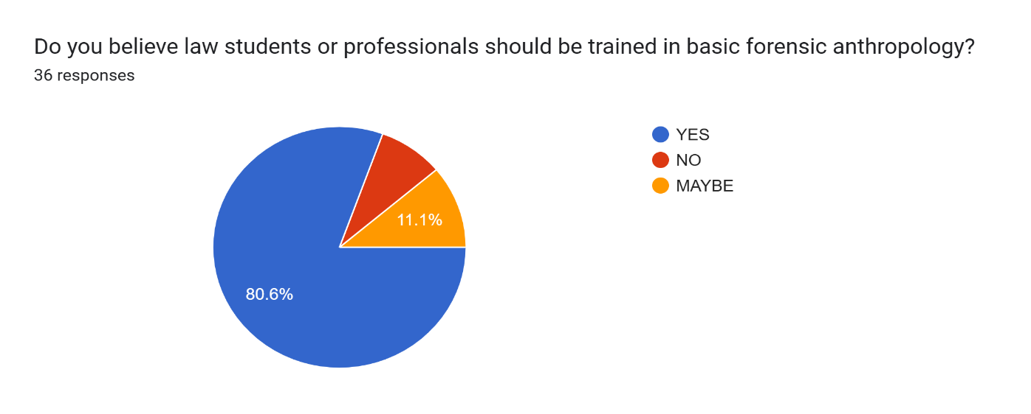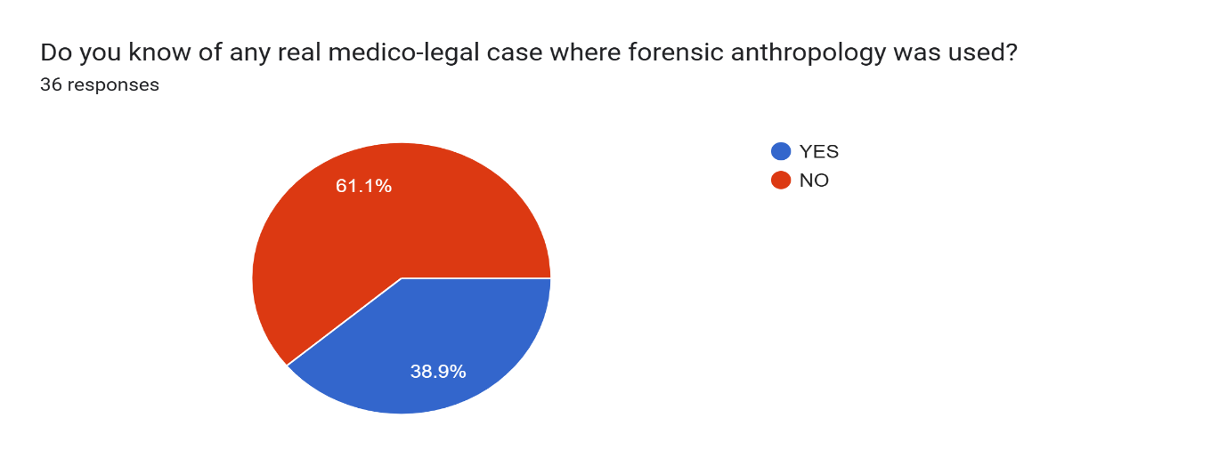

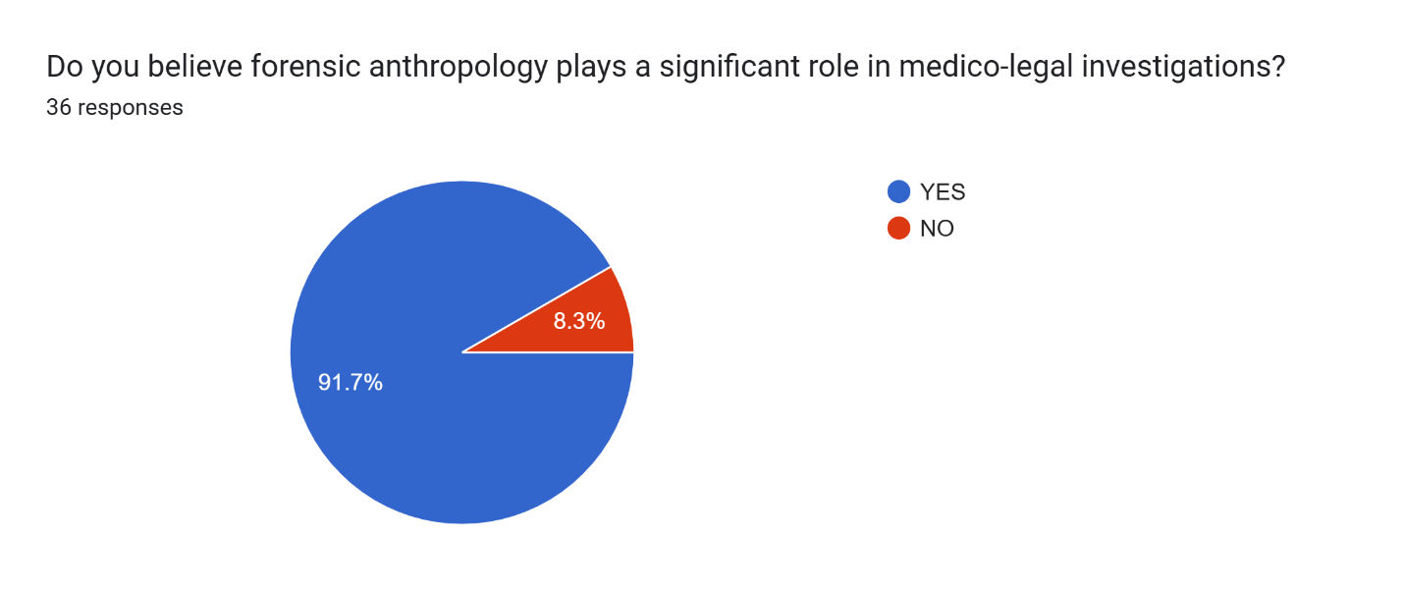

The survey shows that majority of respondents support the inclusion of basic forensic anthropology training for law students and professional and public awareness of real medico legal cases remains low despite respondent is strongly recognized the significance of anthropology as it plays an important role in medical legal investigation. Overall, the data shows a high appreciation for the importance of anthropology combined with a need for awareness and exposure in legal and academic fields.
Conclusion:
Forensic anthropology plays a crucial role in human identification by analyzing skeletal remains, dental features, DNA, and facial reconstruction, especially in cases where traditional methods fail. Despite challenges like degraded remains, ethical concerns, and limited resources, advancements such as virtual anthropology and DNA sequencing have greatly enhanced accuracy and reliability. Indian case studies, including the Nithari killings and the 2004 tsunami, highlight its medico-legal value. With continued technological growth and ethical sensitivity, forensic anthropology will remain an indispensable tool in delivering truth and justice.
Suggestions:
- Establish dedicated forensic anthropology laboratories in every state.
- Introducing forensic anthropology modules in medical law and forensic science curricula
- Improve training opportunities and professional development for experts
- Strengthening coordination between police, forensic teams and legal authorities
- Develop national forensic databases (skeleton, dental, DNA)
- Increase funding, resources, and technological upgrades for forensic labs
- Spread awareness through seminars, workshops and public education campaigns

References:
- National Institute of Justice (NIJ), U.S. Department of Justice. (2017). Forensic Anthropology: Current Methods and Practice. – Explores state of remains, financial/resource constraints, and court-related challenges. Jha, D. N. (2005).
- Indian Ocean Tsunami and Forensic Challenges in India.” Indian Journal of Forensic Medicine and Toxicology, 1(1), 1–6. – Case study highlighting difficulties in degraded remains, resource shortages, and mass disaster victim identification in India.
- Sharma, B. R. (2008). “Forensic Considerations in Fire Fatalities: A Review.” Journal of Clinical Forensic Medicine, 15(6), 367–372. – Discusses burnt remains, DNA challenges, and medico-legal issues in fire-related deaths.
- Lemos, Y.V., Furtado, A.N., Lima, A.Z.,Dionìsio, A.S., Moreira Araújo, R., & Cunha, E.(2024).Human identification by medical findings in a forensic anthropology context. Forensic Science Research, 9(3), owae041.
- Lynnerup, N. (2015). Forensic anthropology and human identification. Anthropologischer Anzeiger, 72(4), 353–359.

MANU/SC/0119/2011
(2011) 14 SCC 481
AIR 2012 SC 3565
(1997) 6 SCC 241

