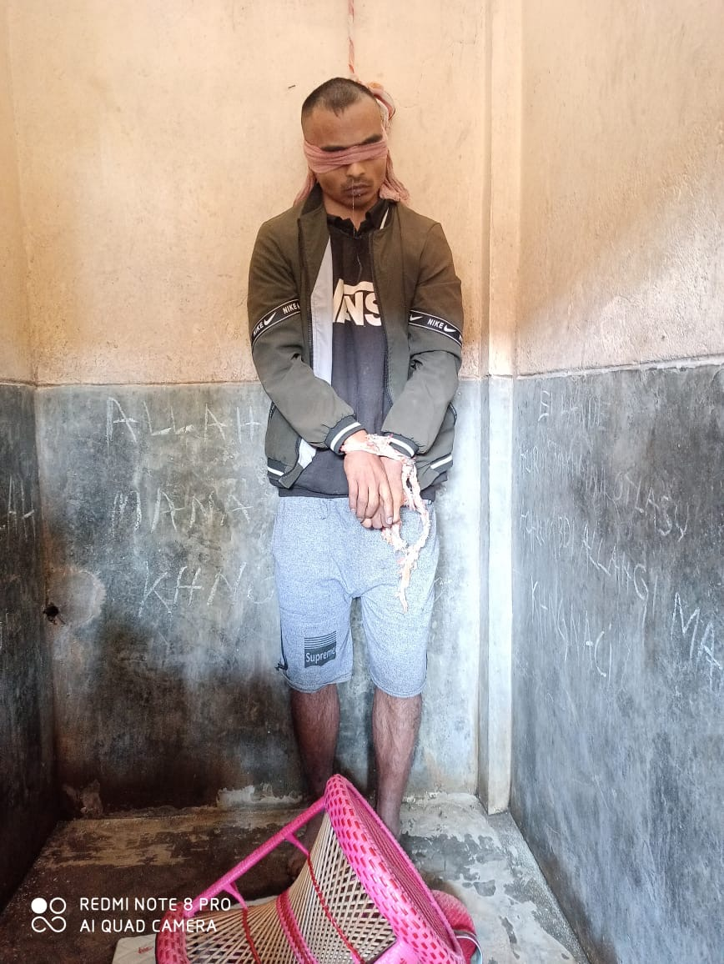
1A
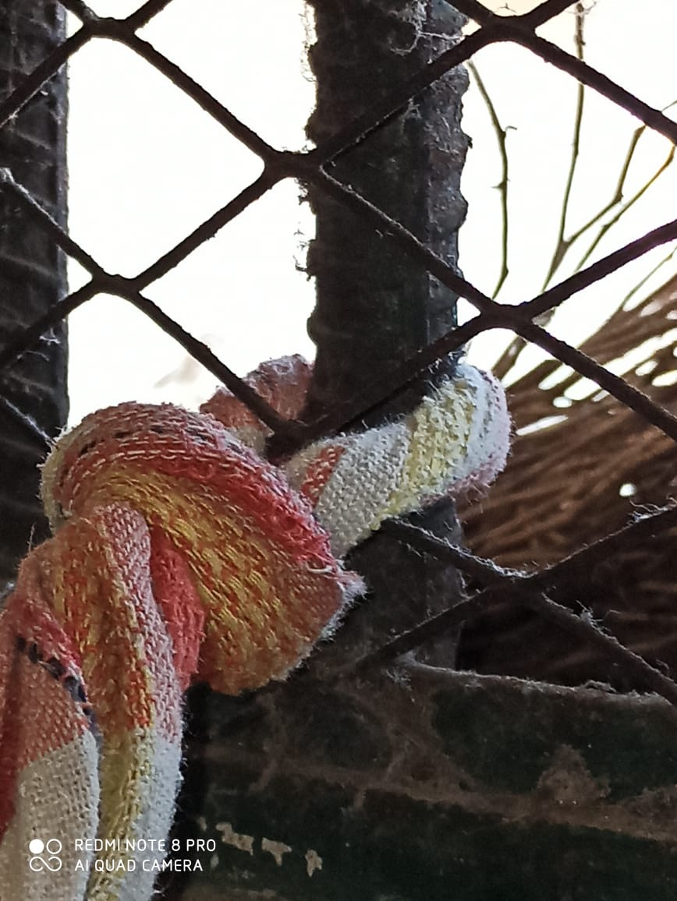
1B
Fig. 1: A)The deceased in partial hanging inside the toilet. B)Point of suspension from the ventilator grill bar

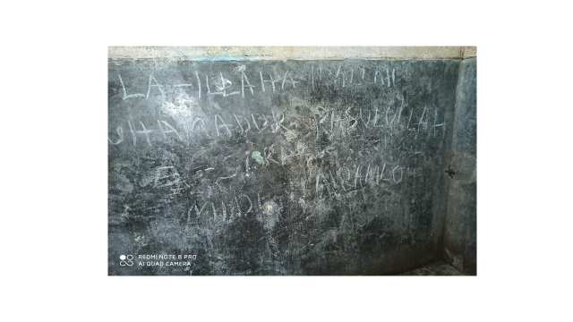
Fig.2 : Notes on the wall

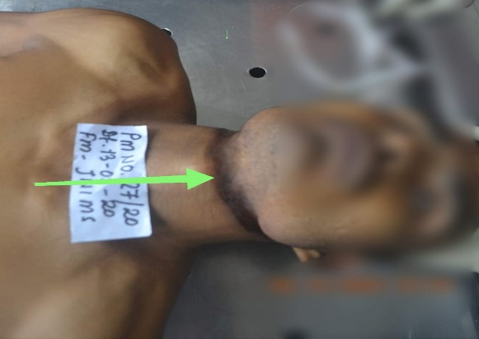
5A
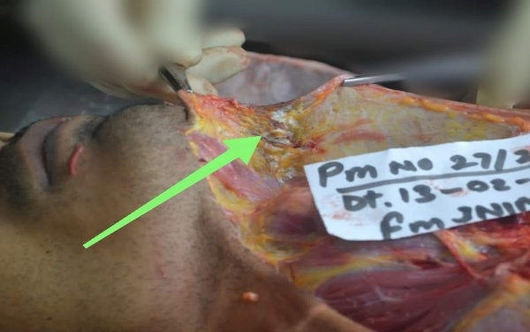
5B
Fig. 5:A) Ligature mark placed obliquely on the neck. B) Dry glistening subcutaneous tissue beneath the ligature mark

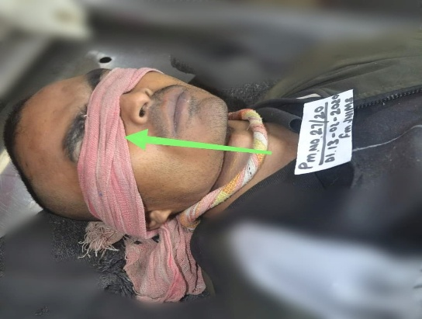
3A
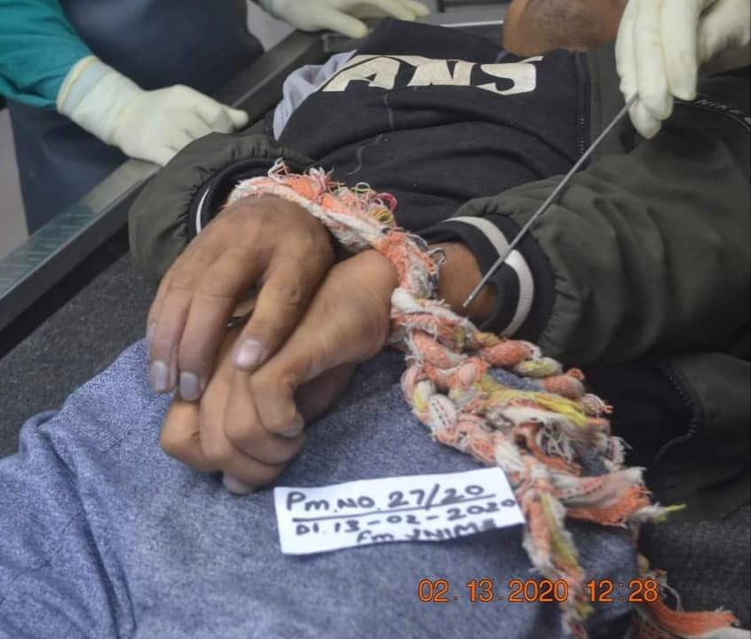
3B
Fig. 3:A) Blinfolded covering both eyes. B) Hands tied in front of the body

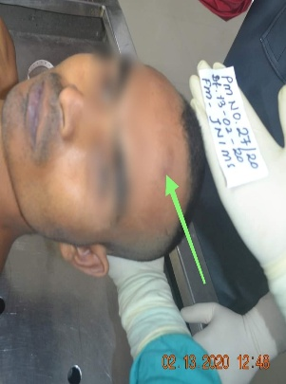  4A | 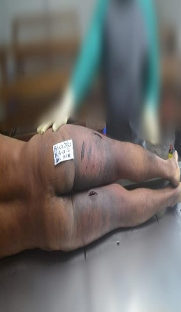  4B
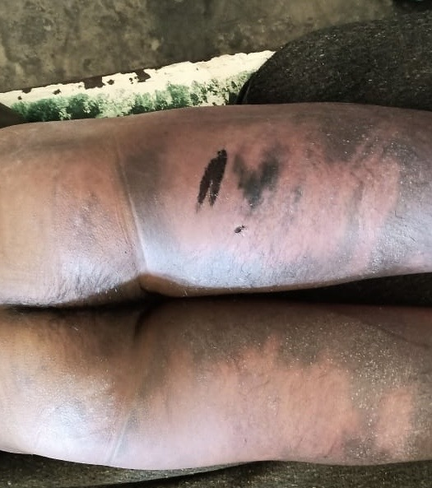
4C
Fig.4:A)Abrasion of left side of forehead. B) Multiple bruise on posterior aspect of both lower limbs. C) Abrasion on posterior aspect of left thigh.

